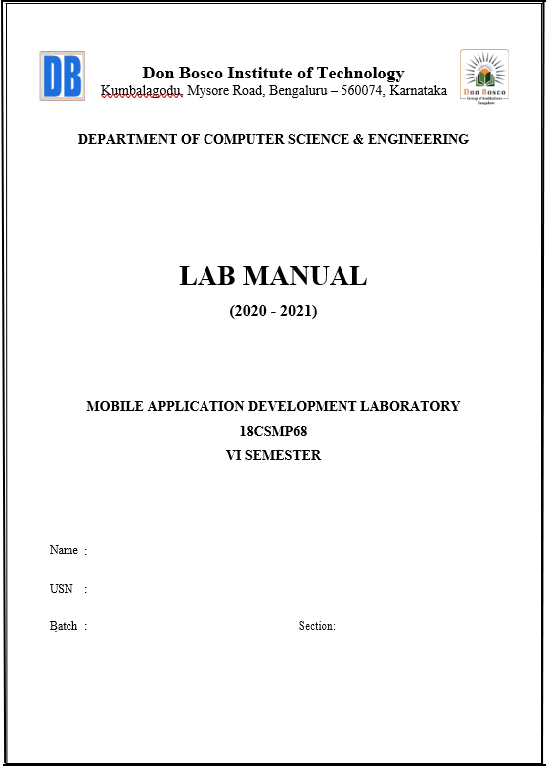

**Course Details**

**Course Name: Mobile Application Development Course Code: 18CSMP68**

**Course prerequisite: Core Java**

**Course Objectives**

**Upon completion of this course, students are expected to:**

### Learn and acquire the art of Android Programming.

* 1. Configure Android studio to run the applications.
  2. Understand and implement Android's User interface functions.
  3. Create, modify and query on SQLite database.
  4. Inspect different methods of sharing data using services.

**SYLLABUS**

**MOBILE APPLICATION DEVELOPMENT**

**Subject Code: 18CSMP68 IA Marks: 40**

**No. of Practical Hrs. / Week: 0:0:2 Exam Marks: 60**

**Total No. of Practical Hrs: 3 Hours/Week Exam Hours: 03 No. of Credits: 02**

**Descriptions (if any):**

1. The installation procedure of the Android Studio/Java software must be demonstrated and carried out in groups.
2. Students should use the latest version of Android Studio/Java/ Kotlin to execute these programs. Diagrams given are for representational purposes only, students are expected to improvise on them.
3. Part B programs should be developed as an application and are to be demonstrated as a mini project in a group by adding extra features or the students can also develop their application and demonstrate it as a mini-project. (Projects/programs are not limited to the list given in Part B).

**Program 1**

**PART A**

Create an application to design a Visiting Card. The Visiting card should have a company logo at the top right corner. The company name should be displayed in Capital letters, aligned to the center. Information like the name of the employee, job title, phone number, address, email, fax and the website address is to be displayed. Insert a horizontal line between the job title and the phone number.

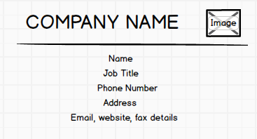

**Program 2**

Develop an Android application using controls like Button, TextView, EditText for designing a Calculator having basic functionality like Addition, Subtraction, Multiplication, and Division.

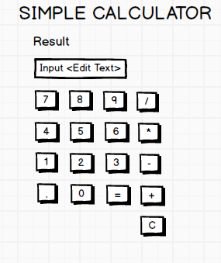

**Program 3**

Create a SIGN Up activity with Username and Password. Validation of password should happen based on the following rules:

* Password should contain uppercase and lowercase letters.
* Password should contain letters and numbers.
* Password should contain special characters.
* Minimum length of the password (the default value is 8).

On successful **SIGN UP** proceed to the next Login activity. Here the user should **SIGN IN** using the Username and Password created during signup activity. If the Username and Password are matched then navigate to the next activity which displays a message saying “Successful Login” or else display a toast message saying “Login Failed”. The user is given only two attempts and after that display a toast message saying “Failed Login Attempts” and disable the SIGN IN button. Use Bundle to transfer information from one activity to another.

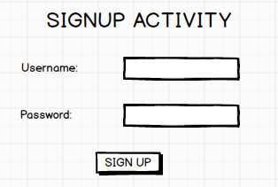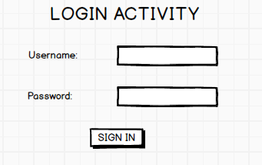

**Program 4**

Develop an application to set an image as wallpaper. On click of a button, the wallpaper image should start to change randomly every 30 seconds.

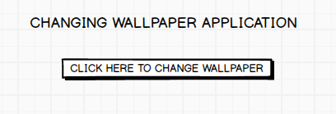

**Program 5**

Write a program to create an activity with two buttons START and STOP. On Pressing of the START button, the activity must start the counter by displaying the numbers from One and the counter must keep on counting until the STOP button is pressed. Display the counter value in a TextView control.

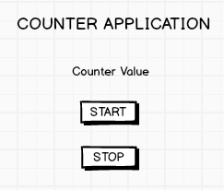

**Program 6**

Create two files of XML and JSON type with values for City_Name, Latitude, Longitude, Temperature, and Humidity. Develop an application to create an activity with two buttons to parse the XML and JSON files which when clicked should display the data in their respective layouts side by side.

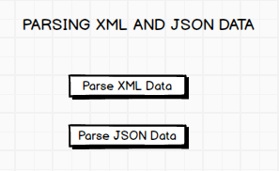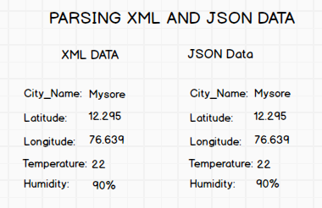

**Program 7**

Develop a simple application with one Edit Text so that the user can write some text in it. Create a button called “Convert Text to Speech” that converts the user input text into voice.

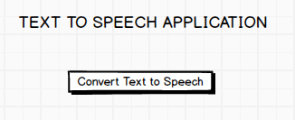

**Program 8**

Create an activity like a phone dialer with CALL and SAVE buttons. On pressing the CALL button, it must call the phone number and on pressing the SAVE button it must save the number to the phone contacts.

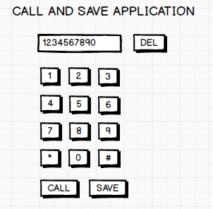

**PART B(TO BE CARRIED OUT AS MINI PROJECT)**

**Program 1**

Write a program to enter Medicine Name, Date and Time of the Day as input from the user and store it in the SQLite database. Input for Time of the Day should be either Morning or Afternoon or Evening or Night. Trigger an alarm based on the Date and Time of the Day and display the Medicine Name.

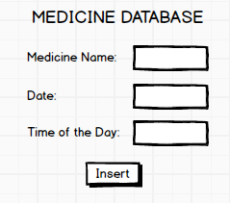

**Program 2**

Develop a content provider application with an activity called “Meeting Schedule” which takes Date, Time and Meeting Agenda as input from the user and store this information into the SQLite database. Create another application with an activity called “Meeting Info” having DatePicker control, which on the selection of a date should display the Meeting Agenda information for that particular date, else it should display a toast message saying “No Meeting on this Date”.

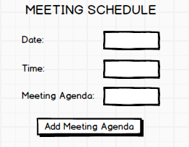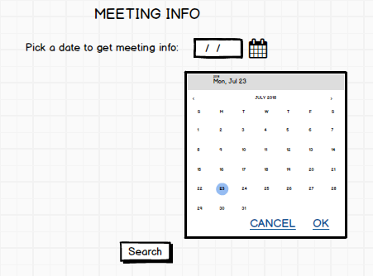

**Program 3**

Create an application to receive an incoming SMS which is notified to the user. On clicking this SMS notification, the message content and the number should be displayed on the screen. Use appropriate emulator control to send the SMS message to your application.

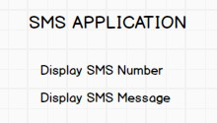

**Program 4**

Write a program to create an activity having a Text box, and also Save, Open and Create buttons. The user has to write some text in the Text box. On pressing the Create button the text should be saved as a text file in MkSDcard. On subsequent changes to the text, the Save button should be pressed to store the latest content to the same file. On pressing the Open button, it should display the contents from the previously stored files in the Text box. If the user tries to save the contents in the Textbox to a file without creating it, then a toast message has to be displayed saying “FirstCreate a File”.

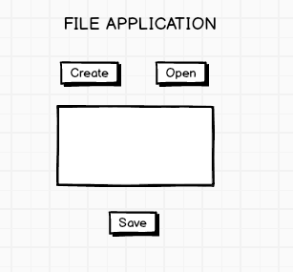

**Program 5**

Create an application to demonstrate a basic media player that allows the user to Forward, Backward, Play and Pause an audio. Also, make use of the indicator in the seek bar to move the audio forward or backward as required.

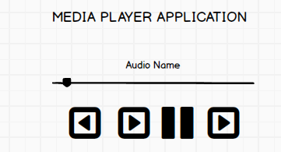

**Program 6**

Develop an application to demonstrate the use of Asynchronous tasks in android. The asynchronous task should implement the functionality of a simple moving banner. On pressing the **Start Task** button, the banner message should scroll from right to left. On pressing the **Stop Task** button, the banner message should stop. Let the banner message be “Demonstration of Asynchronous Task”.

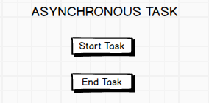

**Program 7**

Develop an application that makes use of the clipboard framework for copying and pasting of the text. The activity consists of two EditText controls and two Buttons to trigger the copy and paste functionality.

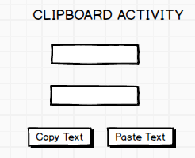

**Program 8**

Create an AIDL service that calculates Car Loan EMI. The formula to calculate EMI is

**E = P * (r(1+r)n)/((1+r)n-1)**

where

E = The EMI payable on the car loan amount P = The Car loan Principal Amount

r = The interest rate value computed on a monthly basis n = The loan tenure in the form of months

The down payment amount has to be deducted from the principal amount paid towards buying the Car. Develop an application that makes use of this AIDL service to calculate the EMI. This application should have four EditText to read the Principal Amount, Down Payment, Interest Rate, Loan Term (in months) and a button named as “Calculate Monthly EMI”. On click of this button, the result should be shown in a TextView. Also, calculate the EMI by varying the Loan Term and Interest Rate values.

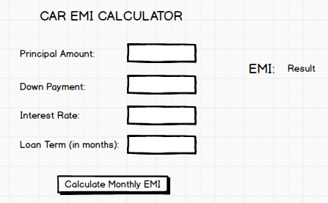

1. **Android Studio Tutorials**
   1. **Install Android Studio and Packages:**

Download Android Version 4.0.2 from the below link [https://redirector.gvt1.com/edgedl/android/studio/install/4.0.2.0/android-studio-ide-](https://redirector.gvt1.com/edgedl/android/studio/install/4.0.2.0/android-studio-ide-193.6821437-windows.exe) [193.6821437-windows.exe](https://redirector.gvt1.com/edgedl/android/studio/install/4.0.2.0/android-studio-ide-193.6821437-windows.exe)

* 1. **Configure Android SDK packages:**

Go to Tools → SDK Manager

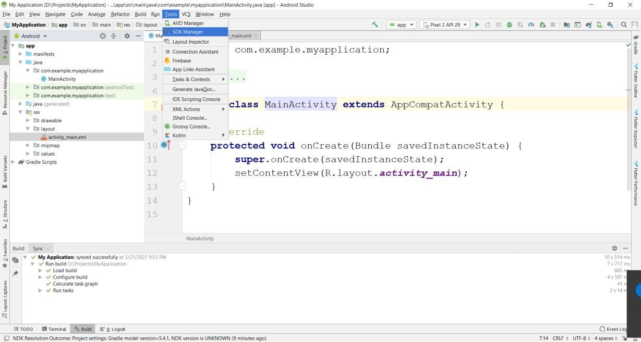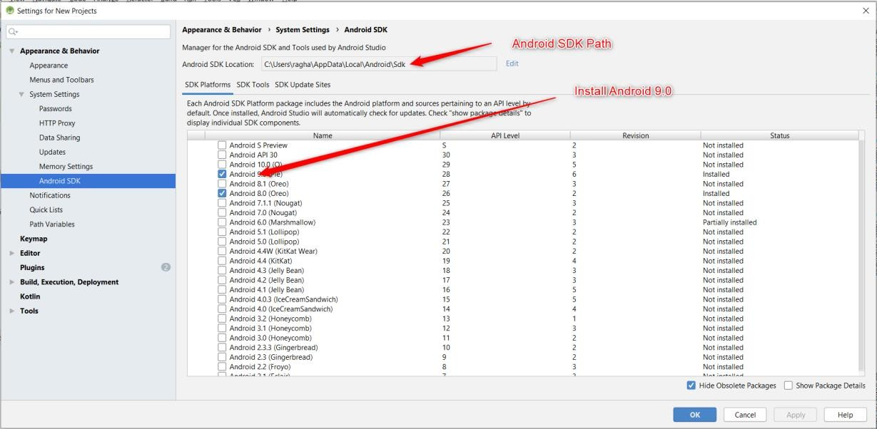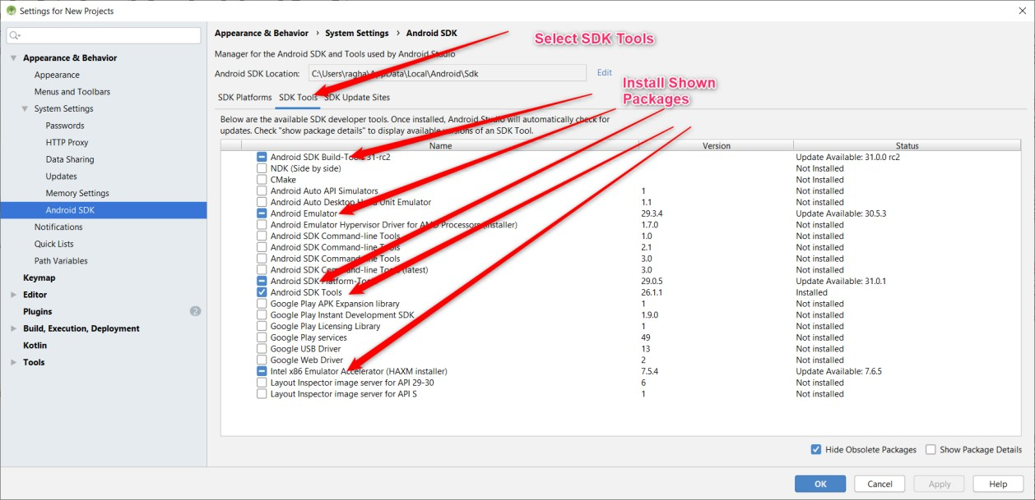

* 1. **Creating Emulator**

Go to Tools → Select AVD Manager

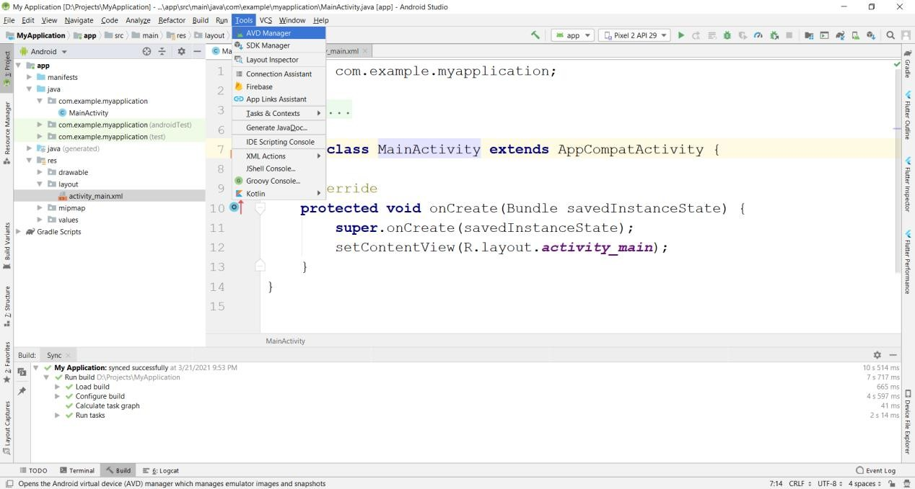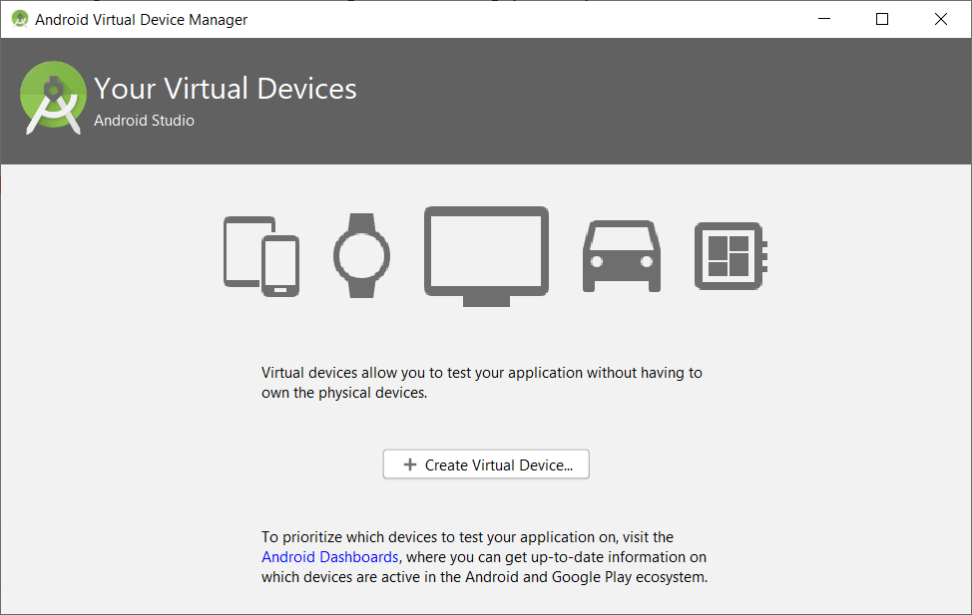

Select Create Virtual Device →Select Phone →Pixel 2 → Press Next

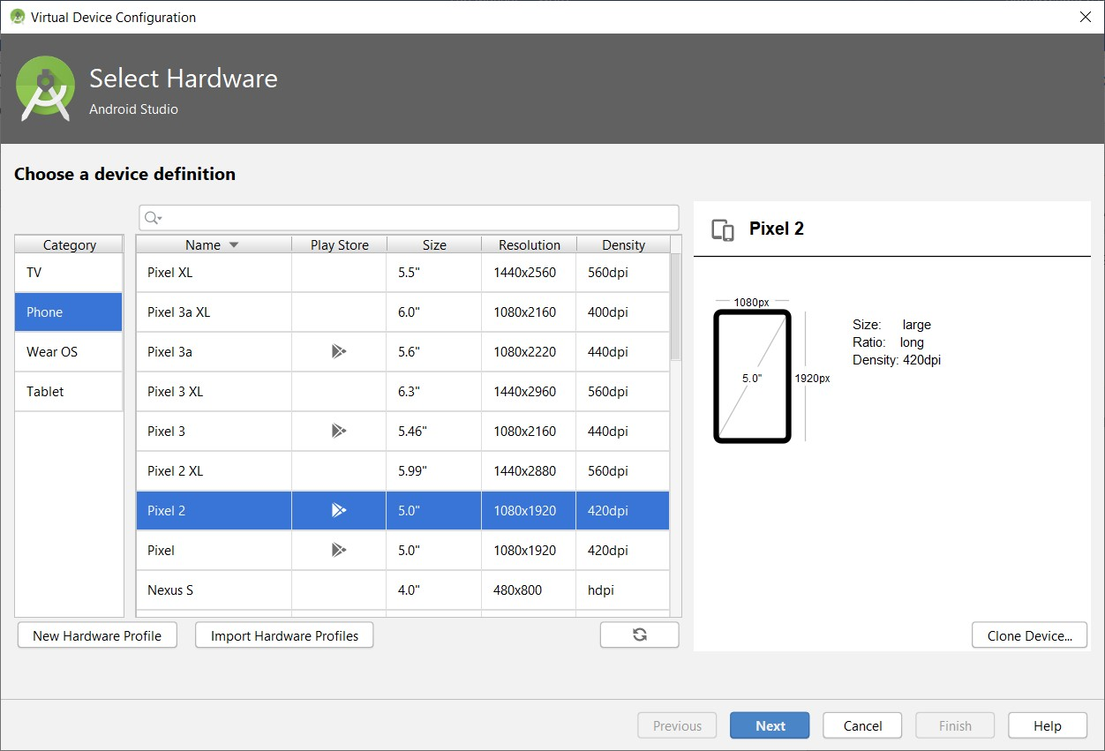

Select Android Q, if not already downloaded press download, After download completes Select Q and Press Next Button.

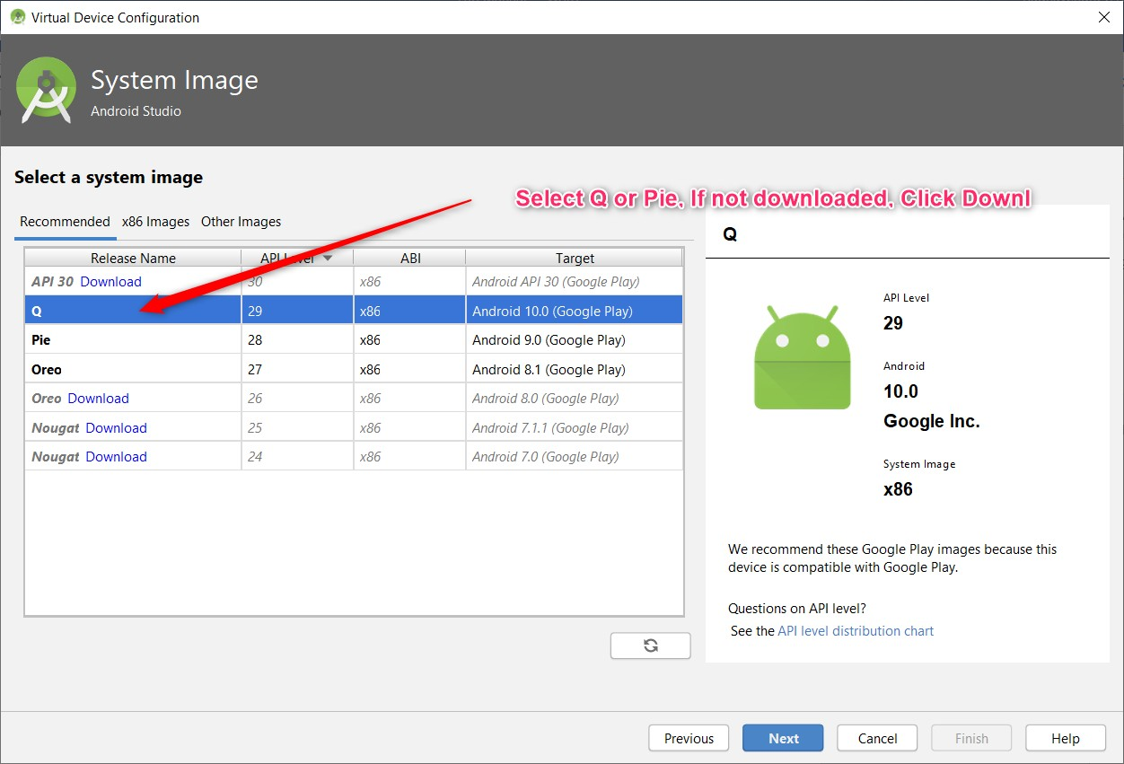

Enter AVD Name and Press Finish.

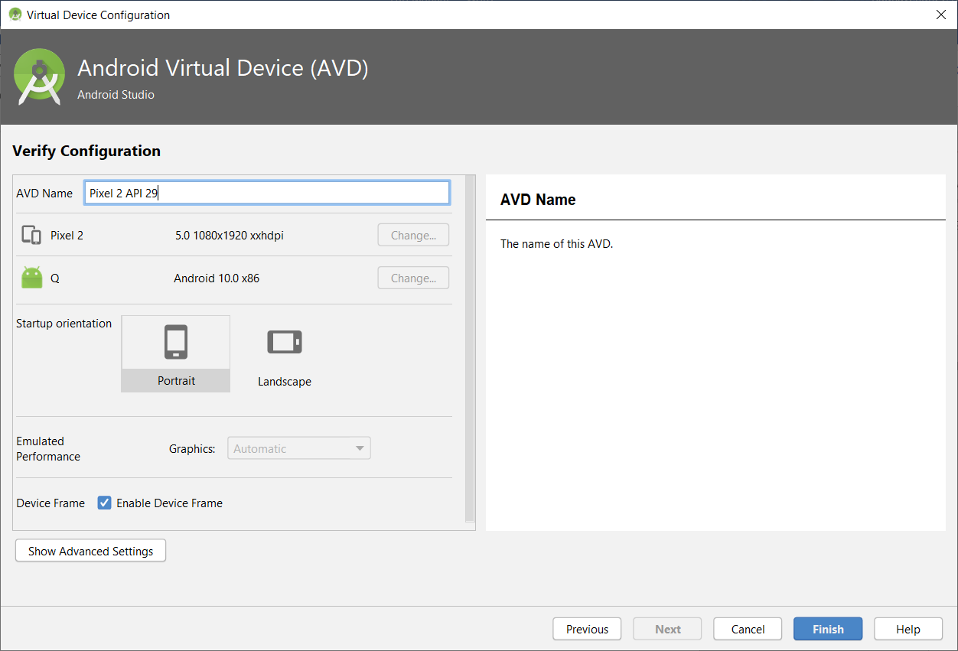

Press Play Button to Start Emulator

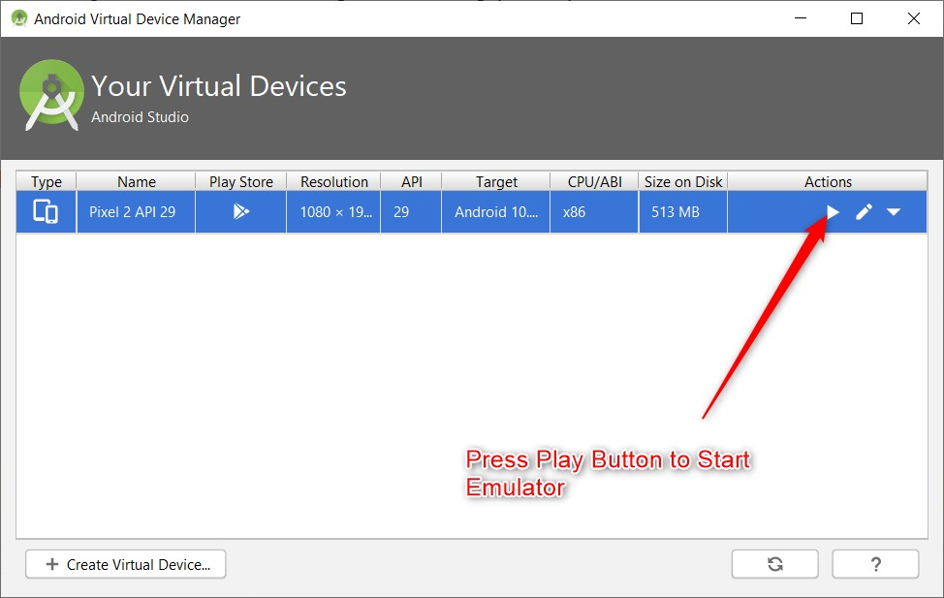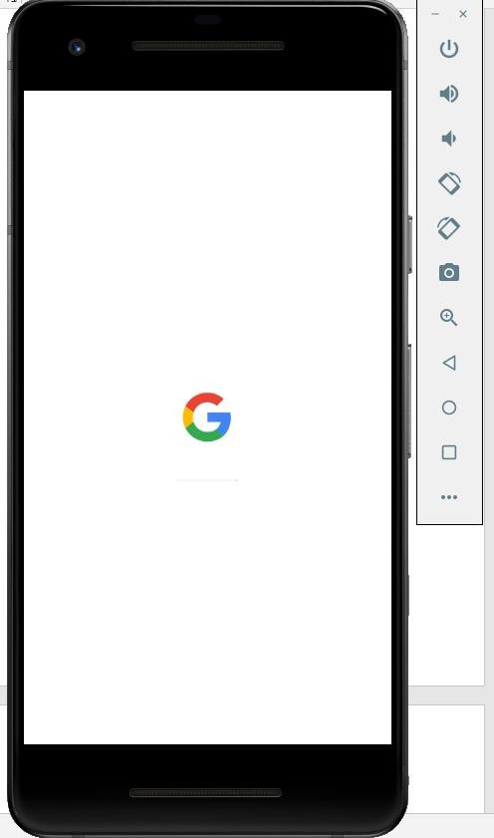

* 1. **Creating a New Project in Android**

While creating a New Project for First Time, make sure Android Studio is connected to internet, It downloads the required packages from internet.

Go to File →New →New Project

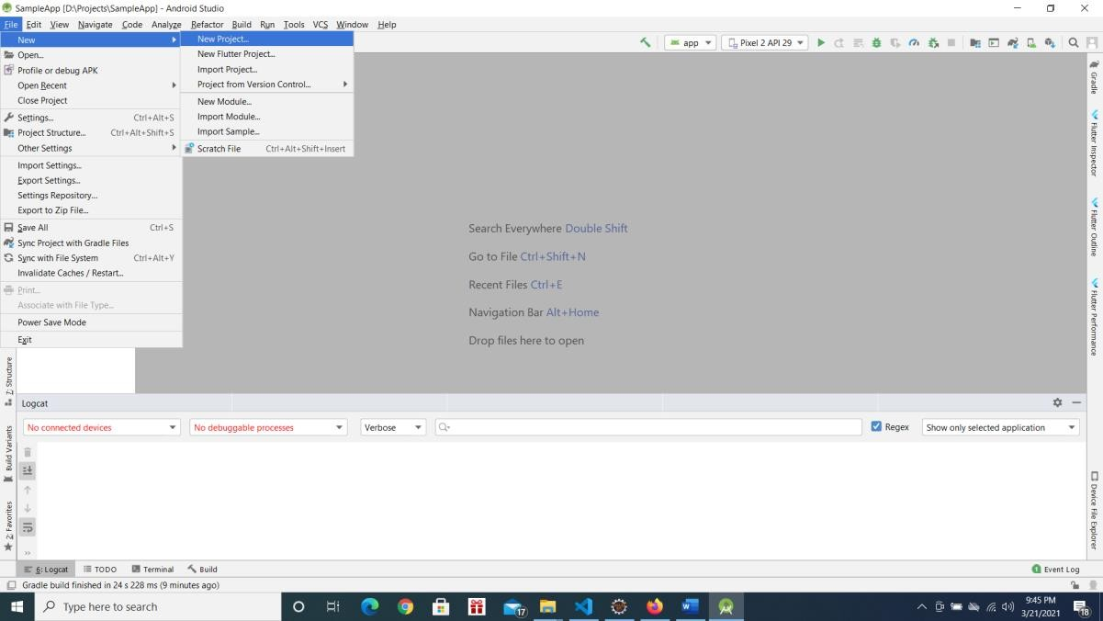

Choose Phone and Tablet → Empty Activity → Press Next

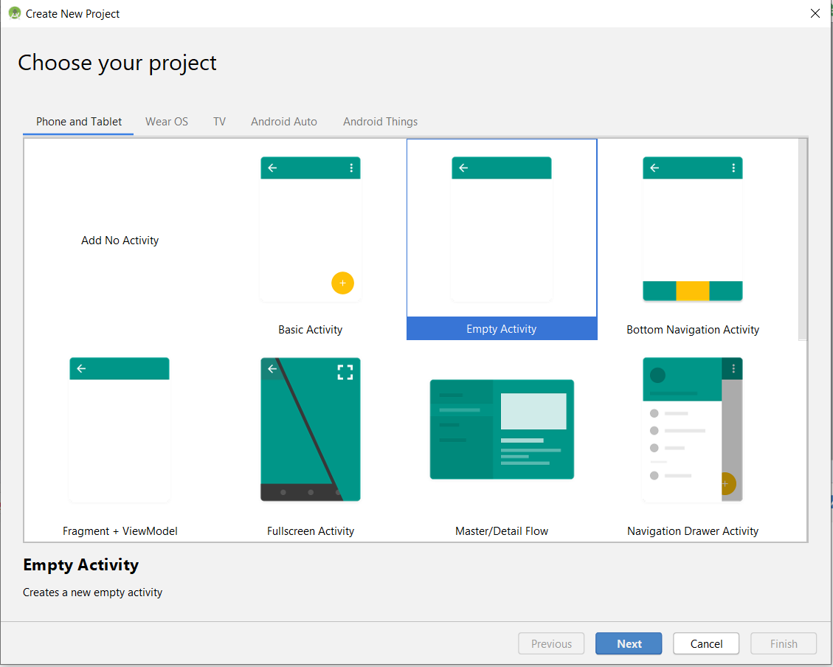

In Configure your Project Screen, Enter below details and Press Finish Button.

Enter Name of the Application → This will be application name this will be visible with Home Screen Icon.

Package Name → Enter package name atleast two identifier (Eg: com.example). Best Practice is 3 or more identifier (Eg: com.example.firstapp).

Save Location →Location where to save the Project Language → Choose Java

Minimum API Level → Android 5.0

Select Checkbox Use androidx.artifacts folder as below screenshot.

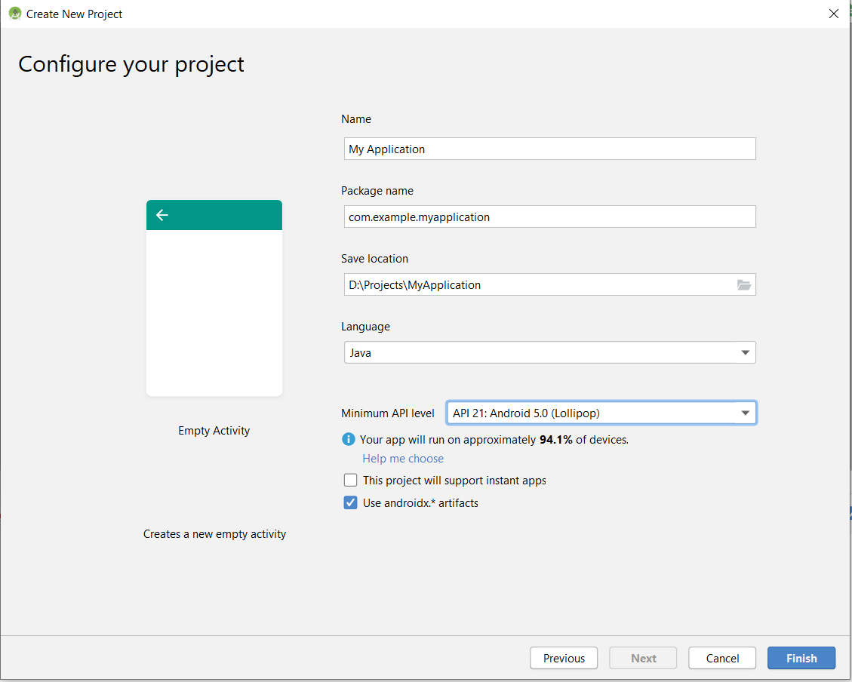

* 1. **Android Project Structure:**

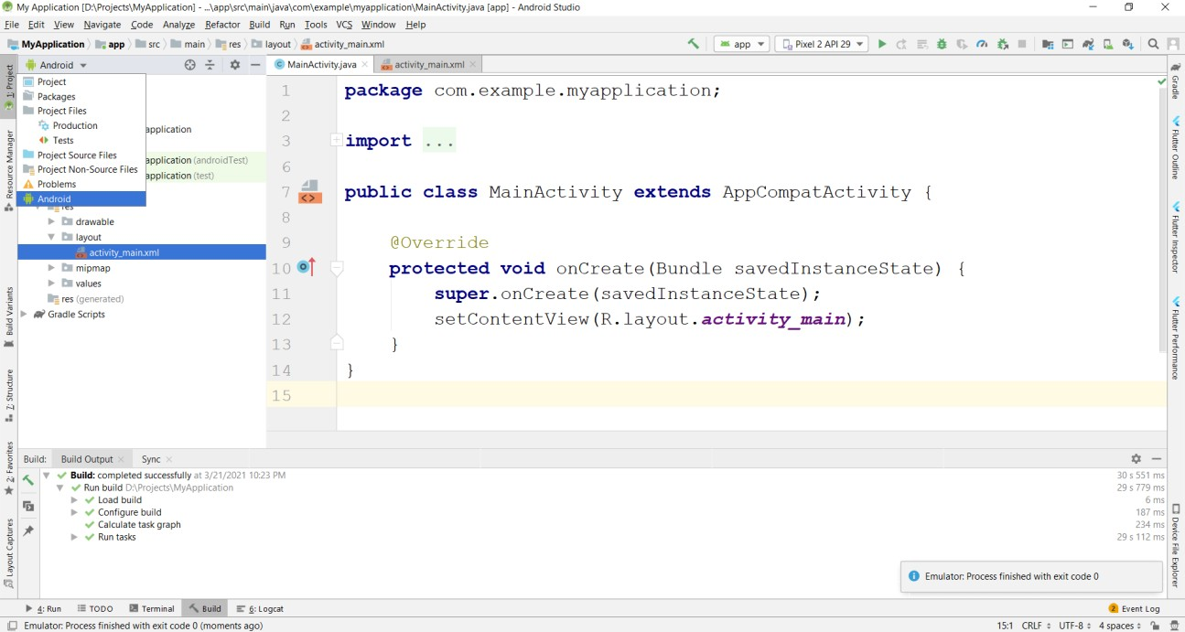

Select Project Explorer and Select Android from Project View

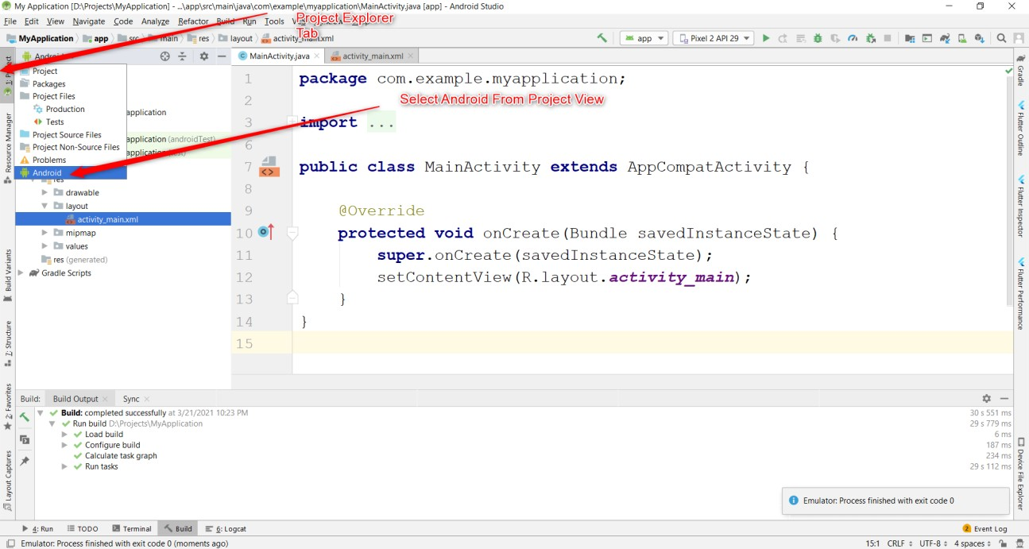

Basic View:

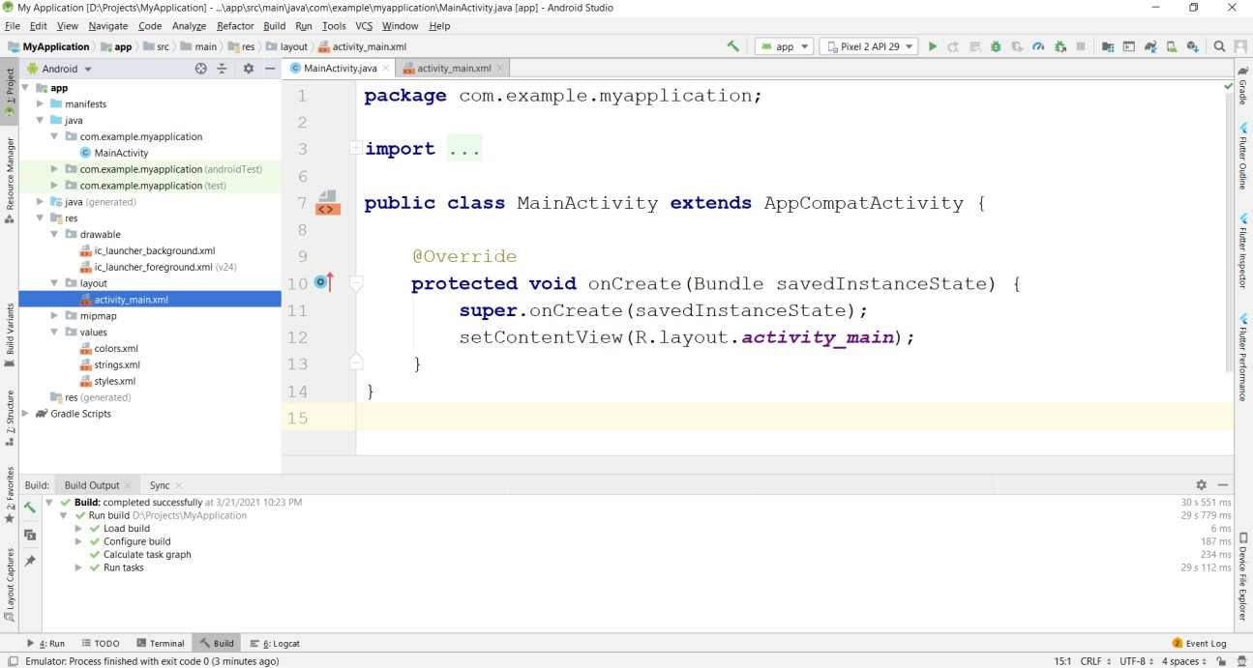

1. Importing an Existing Project in Android Studio
2. Creating an Activity in Android

Right Click on Package → New → Activity→ Empty Activity

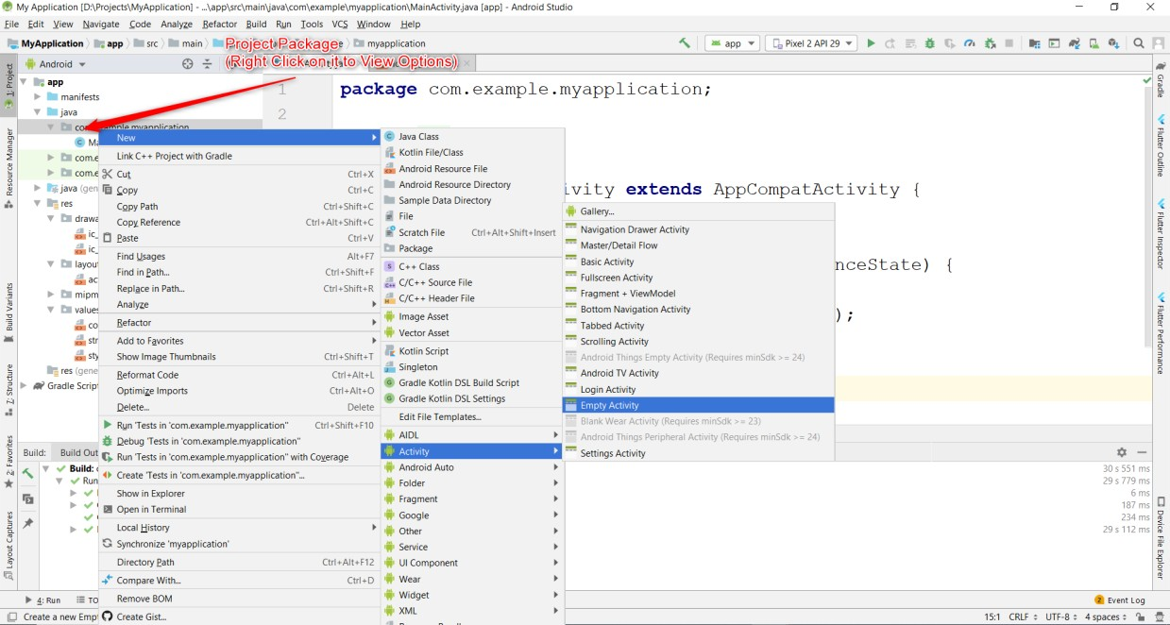

Enter Activity Name and Press Finish

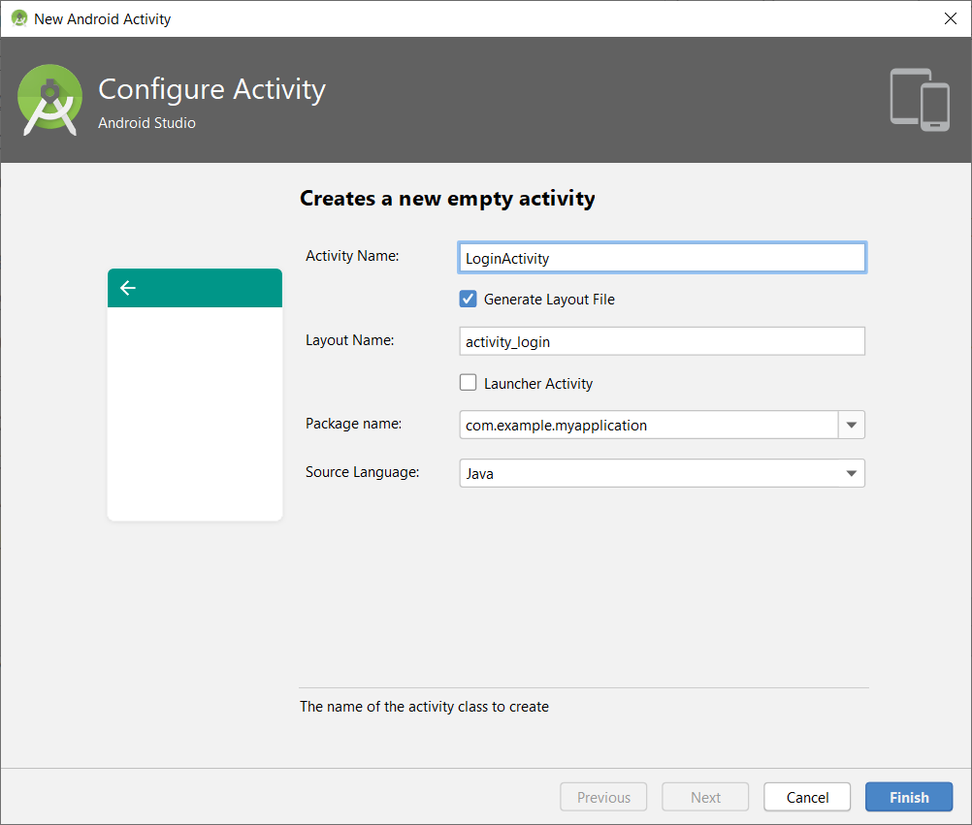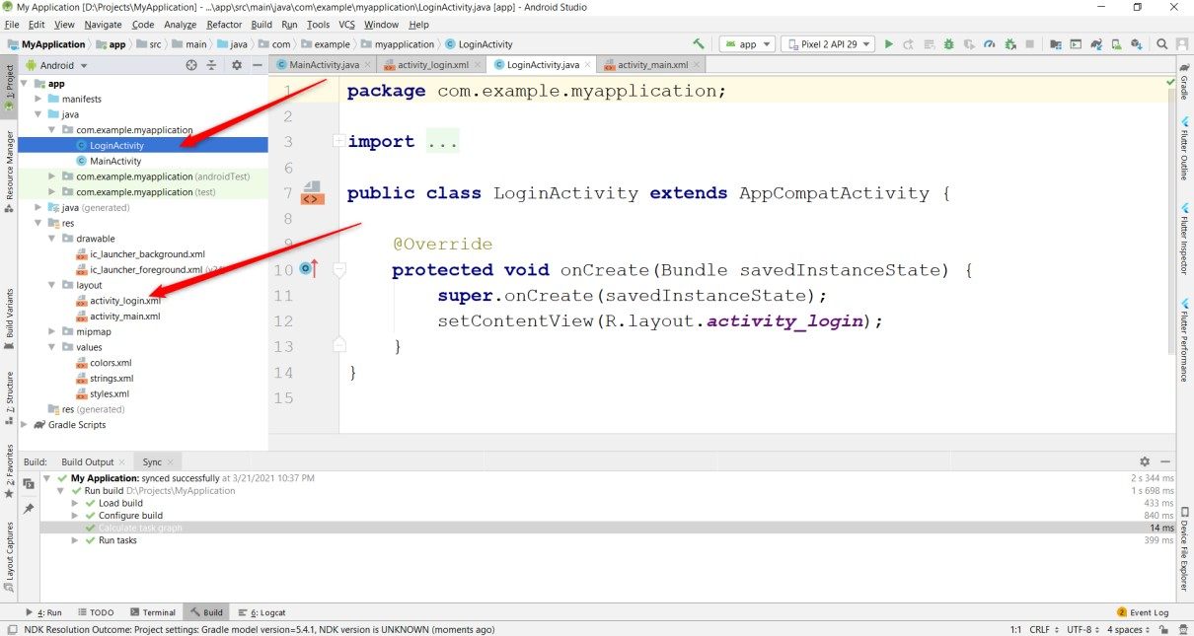

[1]

1. Program-1: Create an application to design a Visiting Card. The Visiting card should have a company logo at the top right corner. The company name should be displayed in Capital letters, aligned to the center. Information like the name of the employee, job title, phone number, address, email, fax and the website address is to be displayed. Insert a horizontal line between the job title and the phone number.

   1. Firstly Create an Application by Name “VisitingCardApp”
   2. Go to xml code of design change the layout to “RelativeLayout”

   3) Add TextView component change the following properties:

   • Size: 38dp

   • Text: DBIT

   • Align left top

   4) Add ImageView to design

   • Download the logo & copy the same in res->drawable folder

   • In xml code of imageview change srcCompat=”@drawable/logo”

   • Align right top

   5) Add View component & change the following properties:

   • Height: 4dp

   • Background: “#4444” (black color)

   6) Add TextView component change the following properties:

   • Size: 20dp

   • Text: Prakruthi S T

   • Style: Bold

   • Align center

   7) Add TextView component change the following properties:

   • Size: 20dp

   • Text: Assistant Professor

   • Align center

   8) Add TextView component change the following properties:

   • Size: 20dp

   • Text: Phone-9876543210

   9) Add TextView component change the following properties:

   • Size: 20dp

   • Text: Dept. of CSE, DBIT, Bengaluru

   • Align: center

   10) Add TextView component change the following properties:

   • Size: 20dp

   • Text: Email-prakruthit@dbit.co.in

   • Align: center

   XML-CODE

   <? xml version="1.0" encoding="utf-8" ?>

   <RelativeLayout xmlns:android="http://schemas.android.com/apk/res/android"

   xmlns:app="http://schemas.android.com/apk/res-auto"

   xmlns:tools="http://schemas.android.com/tools"

   android:layout_width="match_parent"

   android:layout_height="match_parent"

   tools:context=".MainActivity">

   <TextView

   android:id="@+id/textView"

   android:layout_width="wrap_content"

   android:layout_height="wrap_content"

   android:layout_alignParentEnd="true"

   android:layout_alignParentRight="true"

   android:layout_alignParentBottom="true"

   android:layout_marginStart="17dp"

   android:layout_marginLeft="17dp"

   android:layout_marginTop="17dp"

   android:layout_marginEnd="244dp"

   android:layout_marginRight="244dp"

   android:layout_marginBottom="486dp"

   android:text="DBIT"

   android:textSize="38dp" />

   <ImageView

   android:id="@+id/imageView"

   android:layout_width="231dp"

   android:layout_height="174dp"

   android:layout_alignParentEnd="true"

   android:layout_alignParentRight="true"

   android:layout_alignParentBottom="true"

   android:layout_marginEnd="-14dp"

   android:layout_marginRight="-14dp"

   android:layout_marginBottom="481dp"

   app:srcCompat="@drawable/dbitlogo" />

   <View

   android:id="@+id/view"

   android:layout_width="wrap_content"

   android:layout_height="4dp"

   android:layout_alignParentBottom="true"

   android:background="#4444"

   android:layout_marginBottom="466dp" />

   <TextView

   android:id="@+id/textView2"

   android:layout_width="wrap_content"

   android:layout_height="wrap_content"

   android:layout_alignParentEnd="true"

   android:layout_alignParentRight="true"

   android:layout_alignParentBottom="true"

   android:layout_marginEnd="117dp"

   android:layout_marginRight="117dp"

   android:layout_marginBottom="394dp"

   android:text="Prakruthi S T"

   android:textSize="30dp"

   android:textStyle="bold" />

   <TextView

   android:id="@+id/textView3"

   android:layout_width="wrap_content"

   android:layout_height="wrap_content"

   android:layout_alignParentEnd="true"

   android:layout_alignParentRight="true"

   android:layout_alignParentBottom="true"

   android:layout_marginEnd="64dp"

   android:layout_marginRight="64dp"

   android:layout_marginBottom="343dp"

   android:text="Assistant Professor"

   android:textSize="25dp" />

   <TextView

   android:id="@+id/textView4"

   android:layout_width="wrap_content"

   android:layout_height="wrap_content"

   android:layout_alignParentEnd="true"

   android:layout_alignParentRight="true"

   android:layout_alignParentBottom="true"

   android:layout_marginEnd="127dp"

   android:layout_marginRight="127dp"

   android:layout_marginBottom="294dp"

   android:text="Ph No: 9876543210"

   android:textSize="20dp" />

   <TextView

   android:id="@+id/textView5"

   android:layout_width="wrap_content"

   android:layout_height="wrap_content"

   android:layout_alignParentEnd="true"

   android:layout_alignParentRight="true"

   android:layout_alignParentBottom="true"

   android:layout_marginEnd="10dp"

   android:layout_marginRight="10dp"

   android:layout_marginBottom="229dp"

   android:text="Dept. of CSE, DBIT, Bengaluru"

   android:textSize="20dp" />

   <TextView

   android:id="@+id/textView6"

   android:layout_width="wrap_content"

   android:layout_height="wrap_content"

   android:layout_alignParentEnd="true"

   android:layout_alignParentRight="true"

   android:layout_alignParentBottom="true"

   android:layout_marginEnd="44dp"

   android:layout_marginRight="44dp"

   android:layout_marginBottom="189dp"

   android:text="Email: prakruthist@dbit.co.in"

   android:textSize="20dp" />

   </RelativeLayout>

   JAVA-CODE

   import androidx.appcompat.app.AppCompatActivity;

   import android.os.Bundle;

   public class MainActivity extends AppCompatActivity {

   protected void onCreate(Bundle savedInstanceState) {

   super.onCreate(savedInstanceState);

   setContentView(R.layout.activity_main);

   }

   }

   OUTPUT:

   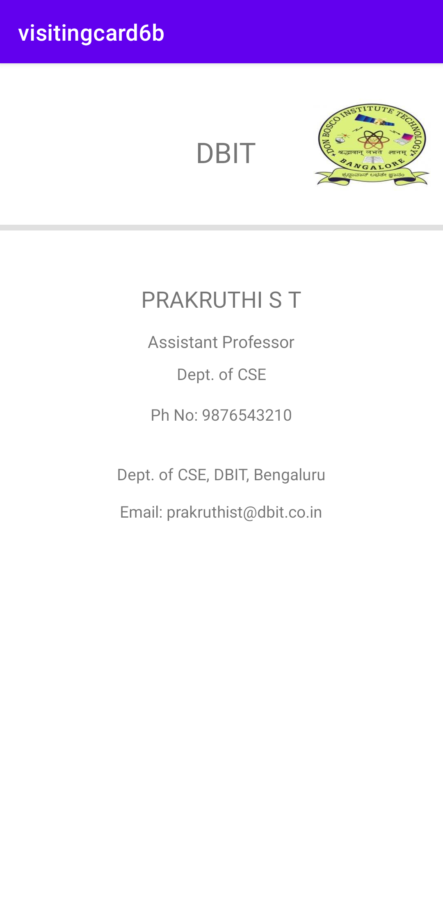

   Program-2: Develop an Android application using controls like Button, TextView, EditText for designing a calculator having basic functionality like Addition, Subtraction, Multiplication, and Division.

   1) Firstly Create an Application by Name “SimpleCalci”

   2) Go to xml code of design change the layout to “RelativeLayout”

   3) Add TextView component & change the following properties:

   • Size: 38dp

   • Text: Simple Calci

   • Center-Align

   4) Add PlainText(EditText) component & change the following properties in XML Code:

   • Text: “”

   • Hint: “Enter the first number”

   • id: “@+id/editText1”

   5) Add PlainText(EditText) component & change the following properties in XML Code:

   • Text: “”

   • Hint: “Enter the second number”

   • id: “@+id/editText2”

   6) Add TextView component to display result & change the following properties:

   • Size: 40dp

   • Text: “0”

   • Center-Align

   • id: “@+id/textView1”

   7) Add 4 Buttons & rename the four buttons “Add”, “Sub”,”Mul” and “div” with following addition:

   • Onclick: “doAdd”(Add Button)

   • Onclick: “doSub”(Sub Button)

   • Onclick: “doMul”(Mul Button)

   • Onclick: “doDiv”(Div Button)

   XML-CODE:

   <?xml version="1.0" encoding="utf-8"?>

   <RelativeLayout xmlns:android="http://schemas.android.com/apk/res/android"

   xmlns:app="http://schemas.android.com/apk/res-auto"

   xmlns:tools="http://schemas.android.com/tools"

   android:layout_width="match_parent"

   android:layout_height="match_parent"

   tools:context=".MainActivity">

   <TextView

   android:layout_width="wrap_content"

   android:layout_height="wrap_content"

   android:layout_alignParentEnd="true"

   android:layout_alignParentBottom="true"

   android:layout_marginEnd="98dp"

   android:layout_marginBottom="653dp"

   android:text="SIMPLE CALCI"

   android:textSize="38dp"

   app:layout_constraintBottom_toBottomOf="parent"

   app:layout_constraintHorizontal_bias="0.498"

   app:layout_constraintLeft_toLeftOf="parent"

   app:layout_constraintRight_toRightOf="parent"

   app:layout_constraintTop_toTopOf="parent"

   app:layout_constraintVertical_bias="0.042" />

   <EditText

   android:id="@+id/editText1"

   android:layout_width="wrap_content"

   android:layout_height="wrap_content"

   android:layout_alignParentEnd="true"

   android:layout_alignParentBottom="true"

   android:layout_marginEnd="115dp"

   android:layout_marginBottom="547dp"

   android:ems="10"

   android:hint="Enter the First Number"

   android:inputType="textPersonName"

   android:text="" />

   <EditText

   android:id="@+id/editText2"

   android:layout_width="wrap_content"

   android:layout_height="wrap_content"

   android:layout_alignParentEnd="true"

   android:layout_alignParentBottom="true"

   android:layout_marginEnd="111dp"

   android:layout_marginBottom="455dp"

   android:ems="10"

   android:inputType="textPersonName"

   android:hint="Enter the Second Number"

   android:text="" />

   <TextView

   android:id="@+id/textView1"

   android:layout_width="wrap_content"

   android:layout_height="wrap_content"

   android:layout_alignParentEnd="true"

   android:layout_alignParentBottom="true"

   android:layout_marginEnd="203dp"

   android:layout_marginBottom="350dp"

   android:text="0"

   android:textSize="40dp" />

   <Button

   android:id="@+id/button"

   android:layout_width="wrap_content"

   android:layout_height="wrap_content"

   android:layout_alignParentEnd="true"

   android:layout_alignParentBottom="true"

   android:layout_marginEnd="274dp"

   android:layout_marginBottom="237dp"

   android:onClick="doAdd"

   android:text="ADD" />

   <Button

   android:id="@+id/button2"

   android:layout_width="wrap_content"

   android:layout_height="wrap_content"

   android:layout_alignParentEnd="true"

   android:layout_alignParentBottom="true"

   android:layout_marginEnd="68dp"

   android:layout_marginBottom="233dp"

   android:onClick="doSub"

   android:text="SUB" />

   <Button

   android:id="@+id/button3"

   android:layout_width="wrap_content"

   android:layout_height="wrap_content"

   android:layout_alignParentEnd="true"

   android:layout_alignParentBottom="true"

   android:layout_marginEnd="277dp"

   android:layout_marginBottom="115dp"

   android:onClick="doMul"

   android:text="MUL" />

   <Button

   android:id="@+id/button4"

   android:layout_width="wrap_content"

   android:layout_height="wrap_content"

   android:layout_alignParentEnd="true"

   android:layout_alignParentBottom="true"

   android:layout_marginEnd="63dp"

   android:layout_marginBottom="104dp"

   android:onClick="doDiv"

   android:text="DIV" />

   </RelativeLayout>

   JAVA-CODE:

   import androidx.appcompat.app.AppCompatActivity;

   import android.os.Bundle;

   import android.view.View;

   import android.widget.EditText;

   import android.widget.TextView;

   public class MainActivity extends AppCompatActivity {

   EditText e1,e2;

   TextView tv1;

   @Override

   protected void onCreate(Bundle savedInstanceState) {

   super.onCreate(savedInstanceState);

   setContentView(R.layout.activity_main);

   e1 = (EditText)findViewById(R.id.editText1);

   e2 = (EditText)findViewById(R.id.editText2);

   tv1 = (TextView)findViewById(R.id.textView1);

   }

   public void doAdd(View V){

   int a1 = Integer.parseInt(e1.getText().toString());

   int a2 = Integer.parseInt(e2.getText().toString());

   int result= a1+a2;

   tv1.setText(""+result);

   }

   public void doSub(View V){

   int a1 = Integer.parseInt(e1.getText().toString());

   int a2 = Integer.parseInt(e2.getText().toString());

   int result= a1-a2;

   tv1.setText(""+result);

   }

   public void doMul(View V){

   int a1 = Integer.parseInt(e1.getText().toString());

   int a2 = Integer.parseInt(e2.getText().toString());

   int result= a1*a2;

   tv1.setText(""+result);

   }

   public void doDiv(View V){

   int a1 = Integer.parseInt(e1.getText().toString());

   int a2 = Integer.parseInt(e2.getText().toString());

   float result= a1/a2;

   tv1.setText(""+result);

   }

   }

   OUTPUT:

   |  |  |
   | --- | --- |
   |  |  |

   Program-3: Create a SIGN Up activity with Username and Password. Validation of password should happen based on the following rules:

   • Password should contain uppercase and lowercase letters.

   • Password should contain letters and numbers.

   • Password should contain special characters.

   • Minimum length of the password (the default value is 8).

   On successful SIGN UP proceed to the next Login activity. Here the user should SIGN IN using the Username and Password created during signup activity. If the Username and Password are matched then navigate to the next activity which displays a message saying “Successful Login” or else display a toast message saying “Login Failed”. The user is given only two attempts and after that display a toast message saying “Failed Login Attempts” and disable the SIGN IN button. Use Bundle to transfer information from one activity to another.

   1. Go to xml code of design Firstly Create an Application by Name “SignUpActivity”
   2. change the layout to “RelativeLayout”

   3) Add TextView component & change the following properties:

   • Size: 38dp

   • Text: “Sign Up”

   • Center-Align

   4) Add Email (EditText) component & change the following properties in XML Code:

   • Hint: “Email ID”

   • id: “@+id/emailEditText”

   5) Add Password (EditText) component & change the following properties in XML

   Code:

   • Hint: “Password”

   • id: “@+id/passwordEditText”

   6) Add Button component & change the following properties in XML

   • Id: “@+id/signBtn”

   • Text: “Sign Up”

   XML-CODE

   <?xml version="1.0" encoding="utf-8"?>

   <RelativeLayout xmlns:android="http://schemas.android.com/apk/res/android"

   xmlns:app="http://schemas.android.com/apk/res-auto"

   xmlns:tools="http://schemas.android.com/tools"

   android:layout_width="match_parent"

   android:layout_height="match_parent"

   tools:context=".MainActivity">

   <TextView

   android:layout_width="160dp"

   android:layout_height="42dp"

   android:layout_alignParentEnd="true"

   android:layout_alignParentBottom="true"

   android:layout_marginEnd="112dp"

   android:layout_marginBottom="573dp"

   android:text="Sign Up"

   android:textSize="28dp"

   app:layout_constraintBottom_toBottomOf="parent"

   app:layout_constraintLeft_toLeftOf="parent"

   app:layout_constraintRight_toRightOf="parent"

   app:layout_constraintTop_toTopOf="parent" />

   <EditText

   android:id="@+id/emailEditText"

   android:layout_width="wrap_content"

   android:layout_height="wrap_content"

   android:layout_alignParentEnd="true"

   android:layout_alignParentBottom="true"

   android:layout_marginEnd="29dp"

   android:layout_marginBottom="431dp"

   android:ems="10"

   android:hint="Email ID"

   android:inputType="textEmailAddress"

   android:textSize="28dp" />

   <EditText

   android:id="@+id/passwordEditText"

   android:layout_width="wrap_content"

   android:layout_height="wrap_content"

   android:layout_alignParentEnd="true"

   android:layout_alignParentBottom="true"

   android:layout_marginEnd="34dp"

   android:layout_marginBottom="345dp"

   android:ems="10"

   android:hint="Password"

   android:inputType="textPassword"

   android:textSize="28dp" />

   <Button

   android:id="@+id/signUpBtn"

   android:layout_width="wrap_content"

   android:layout_height="wrap_content"

   android:layout_alignParentEnd="true"

   android:layout_alignParentBottom="true"

   android:layout_marginEnd="106dp"

   android:layout_marginBottom="226dp"

   android:text="Sign Up"

   android:textSize="28dp" />

   </RelativeLayout>

   JAVA-CODE

   package com.example.loginapplication;

   import androidx.appcompat.app.AppCompatActivity;

   import android.content.Intent;

   import android.os.Bundle;

   import android.view.View;

   import android.widget.Button;

   import android.widget.EditText;

   import android.widget.Toast;

   import java.util.regex.Pattern;

   public class MainActivity extends AppCompatActivity {

   EditText emailEditText, passwordEditText;

   Button signUpBtn;

   @Override

   protected void onCreate(Bundle savedInstanceState) {

   super.onCreate(savedInstanceState);

   setContentView(R.layout.activity_main);

   emailEditText = findViewById(R.id.emailEditText);

   passwordEditText = findViewById(R.id.passwordEditText);

   signUpBtn = findViewById(R.id.signUpBtn);

   signUpBtn.setOnClickListener(new View.OnClickListener() {

   @Override

   public void onClick(View v) {

   String email = emailEditText.getText().toString();

   String password = passwordEditText.getText().toString();

   if (!isValidPassword(password)) {

   Toast.makeText(MainActivity.this, "Password Does not match the rules", Toast.LENGTH_LONG).show();

   return;

   }

   Intent intent = new Intent(MainActivity.this, LoginActivity.class);

   intent.putExtra("email", email);

   intent.putExtra("password", password);

   startActivity(intent);

   }

   });

   }

   Pattern lowercase = Pattern.compile("^.*[a-z].*$");

   Pattern uppercase = Pattern.compile("^.*[A-Z].*$");

   Pattern number = Pattern.compile("^.*[0-9].*$");

   Pattern specialCharacter = Pattern.compile("^.*[^a-zA-Z0-9].*$");

   private Boolean isValidPassword(String password) {

   if (password.length() < 8) {

   return false;

   }

   if (!lowercase.matcher(password).matches()) {

   return false;

   }

   if (!uppercase.matcher(password).matches()) {

   return false;

   }

   if (!number.matcher(password).matches()) {

   return false;

   }

   if (!specialCharacter.matcher(password).matches()) {

   return false;

   }

   return true;

   }

   }

   7) Right click on Java folder-> new-> activity->empty activity-> name it as

   “LoginActivity”

   8) Go to xml code of design change the layout to “RelativeLayout”

   9) Add TextView component & change the following properties:

   • Size: 38dp

   • Text: “Login”

   • Center-Align

   10) Add Email (EditText) component & change the following properties in XML Code:

   • Hint: “Email ID”

   • id: “@+id/emailEditText”

   11) Add Password (EditText) component & change the following properties in XML

   Code:

   • Hint: “Password”

   • id: “@+id/passwordEditText”

   12) Add Button component & change the following properties in XML

   • Id: “@+id/loginBtn”

   • Text: “Login”

   XML-CODE

   <?xml version="1.0" encoding="utf-8"?>

   <RelativeLayout xmlns:android="http://schemas.android.com/apk/res/android"

   xmlns:app="http://schemas.android.com/apk/res-auto"

   xmlns:tools="http://schemas.android.com/tools"

   android:layout_width="match_parent"

   android:layout_height="match_parent"

   tools:context=".LoginActivity">

   <TextView

   android:id="@+id/textView"

   android:layout_width="210dp"

   android:layout_height="54dp"

   android:layout_alignParentEnd="true"

   android:layout_alignParentBottom="true"

   android:layout_marginEnd="120dp"

   android:layout_marginBottom="576dp"

   android:text="Login Activity"

   android:textSize="28dp" />

   <EditText

   android:id="@+id/emailEditText"

   android:layout_width="222dp"

   android:layout_height="80dp"

   android:layout_alignParentEnd="true"

   android:layout_alignParentBottom="true"

   android:layout_marginEnd="108dp"

   android:layout_marginBottom="424dp"

   android:ems="10"

   android:hint="Email ID"

   android:inputType="textEmailAddress"

   android:textSize="28dp" />

   <EditText

   android:id="@+id/passwordEditText"

   android:layout_width="wrap_content"

   android:layout_height="wrap_content"

   android:layout_alignParentEnd="true"

   android:layout_alignParentBottom="true"

   android:layout_marginEnd="40dp"

   android:layout_marginBottom="299dp"

   android:ems="10"

   android:hint="Password"

   android:inputType="textPassword"

   android:textSize="28dp" />

   <Button

   android:id="@+id/loginBtn"

   android:layout_width="wrap_content"

   android:layout_height="wrap_content"

   android:layout_alignParentEnd="true"

   android:layout_alignParentBottom="true"

   android:layout_marginEnd="173dp"

   android:layout_marginBottom="189dp"

   android:text="login"

   android:textSize="26dp" />

   </RelativeLayout>

   JAVA-CODE

   package com.example.loginapplication;

   import androidx.appcompat.app.AppCompatActivity;

   import android.content.Intent;

   import android.os.Bundle;

   import android.view.View;

   import android.widget.Button;

   import android.widget.EditText;

   import android.widget.Toast;

   public class LoginActivity extends AppCompatActivity {

   EditText emailEditText, passwordEditText;

   Button loginBtn;

   int counter=2;

   @Override

   protected void onCreate(Bundle savedInstanceState) {

   super.onCreate(savedInstanceState);

   setContentView(R.layout.activity_login);

   emailEditText=findViewById(R.id.emailEditText);

   passwordEditText=findViewById(R.id.passwordEditText);

   loginBtn=findViewById(R.id.loginBtn);

   String registeredEmail=getIntent().getStringExtra("email");

   String registeredPassword=getIntent().getStringExtra("password");

   loginBtn.setOnClickListener(new View.OnClickListener() {

   @Override

   public void onClick(View v) {

   String email=emailEditText.getText().toString();

   String password=passwordEditText.getText().toString();

   if(registeredEmail.equals(email)&& registeredPassword.equals(password))

   {

   Intent intent=new Intent(LoginActivity.this,LoginSuccessActivity.class);

   startActivity(intent);

   }

   else{

   Toast.makeText(LoginActivity.this,"Invalid

   Credentials",Toast.LENGTH_LONG).show();

   }

   counter--;

   if (counter==0)

   {

   Toast.makeText(getBaseContext(),"FAILED LOGIN

   ATTEMPTS",Toast.LENGTH_LONG).show();

   loginBtn.setEnabled(false);

   }

   }

   });

   }

   }

   13) Right click on Java folder-> new-> activity->empty activity-> name it as

   “LoginSuccessful”

   14) Go to xml code of design change the layout to “RelativeLayout”

   15) Add TextView component & change the following properties:

   • Size: 38dp

   • Text: “Login Successful”

   • Center-Align

   XML-CODE

   <?xml version="1.0" encoding="utf-8"?>

   <RelativeLayout xmlns:android="http://schemas.android.com/apk/res/android"

   xmlns:app="http://schemas.android.com/apk/res-auto"

   xmlns:tools="http://schemas.android.com/tools"

   android:layout_width="match_parent"

   android:layout_height="match_parent"

   tools:context=".LoginSuccessActivity">

   <TextView

   android:id="@+id/textView2"

   android:layout_width="297dp"

   android:layout_height="190dp"

   android:layout_alignParentEnd="true"

   android:layout_alignParentBottom="true"

   android:layout_marginEnd="42dp"

   android:layout_marginBottom="400dp"

   android:text="Login Successful"

   android:textSize="38dp" />

   </RelativeLayout>

   JAVA-CODE

   package com.example.loginapplication;

   import androidx.appcompat.app.AppCompatActivity;

   import android.os.Bundle;

   public class LoginSuccessActivity extends AppCompatActivity {

   @Override

   protected void onCreate(Bundle savedInstanceState) {

   super.onCreate(savedInstanceState);

   setContentView(R.layout.activity_login_success);

   }

   }

   OUTPUT

   |  |  |  |
   | --- | --- | --- |
   |  |  |  |

   Program-4: Develop an application to set an image as wallpaper. On click of a button, the wallpaper image should start to change randomly every 30 seconds.

   1. Firstly Create an Application by Name “WallpaperActivity”
   2. Go to xml code of design change the layout to “RelativeLayout”

   3) Add TextView component & change the following properties:

   • Size: 38dp

   • Text: Wall Paper Change Application

   • Center-Align

   4) Add Button component & change the following properties:

   • Size: 38dp

   • Text: Click Here To Change Wall Paper

   5) Save five images (jpg format) in the drawable folder. In this example one.jpg, two.jpg, three.jpg, four.jpg and five.jpg images are saved in drawable folder.

   XML-CODE

   <?xml version="1.0" encoding="utf-8"?>

   <RelativeLayout xmlns:android="http://schemas.android.com/apk/res/android"

   xmlns:app="http://schemas.android.com/apk/res-auto"

   xmlns:tools="http://schemas.android.com/tools"

   android:layout_width="match_parent"

   android:layout_height="match_parent"

   tools:context=".MainActivity">

   <TextView

   android:id="@+id/textView"

   android:layout_width="210dp"

   android:layout_height="54dp"

   android:layout_alignParentEnd="true"

   android:layout_alignParentBottom="true"

   android:layout_marginEnd="120dp"

   android:layout_marginBottom="576dp"

   android:text="Wall Paper Change Application"

   android:textSize="28dp" />

   <Button

   android:id="@+id/button"

   android:layout_width="wrap_content"

   android:layout_height="wrap_content"

   android:layout_alignParentEnd="true"

   android:layout_alignParentBottom="true"

   android:layout_marginEnd="173dp"

   android:layout_marginBottom="189dp"

   android:text="Click Here To Change Wall Paper"

   android:textSize="26dp" />

   </RelativeLayout>

   JAVA-CODE

   import androidx.appcompat.app.AppCompatActivity;

   import android.app.WallpaperManager;

   import android.graphics.Bitmap;

   import android.graphics.BitmapFactory;

   import android.graphics.drawable.AnimationDrawable;

   import android.graphics.drawable.BitmapDrawable;

   import android.graphics.drawable.Drawable;

   import android.os.Bundle;

   import android.view.View;

   import android.widget.Button;

   import android.widget.Toast;

   import java.io.IOException;

   import java.util.Timer;

   import java.util.TimerTask;

   public class MainActivity extends AppCompatActivity {

   Button changewallpaper;

   Timer mytimer;

   Drawable drawable;

   WallpaperManager wpm;

   int prev=1;

   @Override

   protected void onCreate(Bundle savedInstanceState) {

   super.onCreate(savedInstanceState);

   setContentView(R.layout.activity_main);

   mytimer = new Timer();

   wpm = WallpaperManager.getInstance(this);

   changewallpaper = findViewById(R.id.button);

   changewallpaper.setOnClickListener(new View.OnClickListener() {

   @Override public void onClick(View view) {

   setWallpaper();

   }

   });

   }

   private void setWallpaper() {

   mytimer.schedule(new TimerTask() {

   @Override

   public void run() {

   if(prev==1) {

   drawable = getResources().getDrawable(R.drawable.one);

   prev = 2;

   }

   else if(prev==2) {

   drawable = getResources().getDrawable(R.drawable.two);

   prev=3;

   }

   else if(prev==3) {

   drawable = getResources().getDrawable(R.drawable.three);

   prev=4;

   }

   else if(prev==4) {

   drawable = getResources().getDrawable(R.drawable.four);

   prev=5;

   }

   else if(prev==5) {

   drawable = getResources().getDrawable(R.drawable.five);

   prev=1;

   }

   Bitmap wallpaper = ((BitmapDrawable)drawable).getBitmap();

   try {

   wpm.setBitmap(wallpaper);

   } catch (IOException e) {

   e.printStackTrace();

   }

   }

   },0,30000); } }

   Output:

   |  |  |  |
   | --- | --- | --- |
   |  |  |  |

   Program-5 : Write a program to create an activity with two buttons START and STOP. On pressing of the START button, the activity must start the counter by displaying the numbers from One and the counter must keep on counting until the STOP button is pressed. Display the counter value in a TextViewcontrol.

   1. Firstly Create an Application by Name “CounterActivity”
   2. Go to xml code of design change the layout to “RelativeLayout”

   3) Add TextView component & change the following properties:

   • Size: 38dp

   • Text: “Counter Application”

   • Center-Align

   4) Add TextView component & change the following properties:

   • Text: “Counter Value”

   5) Add Button components & change the following properties:

   • Size: 38dp

   • Text: Start

   • id: “@+id/btn_start”

   6) Add Button components & change the following properties:

   • Size: 38dp

   • Text: Stop

   • id: “@+id/btn_stop”

   XML-CODE

   <?xml version="1.0" encoding="utf-8"?>

   <RelativeLayout xmlns:android="http://schemas.android.com/apk/res/android"

   xmlns:app="http://schemas.android.com/apk/res-auto"

   xmlns:tools="http://schemas.android.com/tools"

   android:layout_width="match_parent"

   android:layout_height="match_parent"

   tools:context=".MainActivity">

   <TextView

   android:layout_width="378dp"

   android:layout_height="68dp"

   android:layout_alignParentEnd="true"

   android:layout_alignParentBottom="true"

   android:layout_marginEnd="18dp"

   android:layout_marginBottom="602dp"

   android:text="Counter Application"

   android:textSize="38dp"

   app:layout_constraintBottom_toBottomOf="parent"

   app:layout_constraintLeft_toLeftOf="parent"

   app:layout_constraintRight_toRightOf="parent"

   app:layout_constraintTop_toTopOf="parent" />

   <TextView

   android:id="@+id/textView"

   android:layout_width="121dp"

   android:layout_height="32dp"

   android:layout_alignParentEnd="true"

   android:layout_alignParentBottom="true"

   android:layout_marginEnd="145dp"

   android:layout_marginBottom="478dp"

   android:text="Counter Value" />

   <Button

   android:id="@+id/btn_start"

   android:layout_width="wrap_content"

   android:layout_height="wrap_content"

   android:layout_alignParentEnd="true"

   android:layout_alignParentBottom="true"

   android:layout_marginEnd="297dp"

   android:layout_marginBottom="295dp"

   android:text="Start" />

   <Button

   android:id="@+id/btn_stop"

   android:layout_width="wrap_content"

   android:layout_height="wrap_content"

   android:layout_alignParentEnd="true"

   android:layout_alignParentBottom="true"

   android:layout_marginEnd="74dp"

   android:layout_marginBottom="292dp"

   android:text="Stop" />

   </RelativeLayout>

   JAVA-CODE

   package com.example.counterapplication;

   import androidx.appcompat.app.AppCompatActivity;

   import android.os.Bundle;

   import android.os.Handler;

   import android.view.View;

   import android.widget.Button;

   import android.widget.TextView;

   public class MainActivity extends AppCompatActivity {

   Button btnstart, btnstop;

   TextView txtcounter;

   int i=1;

   Handler customHandler=new Handler();

   @Override

   protected void onCreate(Bundle savedInstanceState) {

   super.onCreate(savedInstanceState);

   setContentView(R.layout.activity_main);

   btnstart=findViewById(R.id.btn_start);

   btnstop=findViewById(R.id.btn_stop);

   txtcounter=findViewById(R.id.textView);

   btnstart.setOnClickListener(new View.OnClickListener() {

   @Override

   public void onClick(View v) {

   customHandler.postDelayed(updateTimerThread,0);

   }

   });

   btnstop.setOnClickListener(new View.OnClickListener() {

   @Override

   public void onClick(View v) {

   customHandler.removeCallbacks(updateTimerThread);

   }

   });

   }

   private final Runnable updateTimerThread=new Runnable() {

   @Override

   public void run() {

   txtcounter.setText(""+i);

   customHandler.postDelayed(this,1000);

   i++;

   }

   };

   }

   Output:

   |  |  |
   | --- | --- |
   |  |  |

   Program-6: Create two files of XML and JSON type with values for City_Name, Latitude, Longitude, Temperature, and Humidity. Develop an application to create an activity with two buttons to parse the XML and JSON files which when clicked should display the data in their respective layouts side by side.

   1. Firstly Create an Application by Name “JsonParser”
   2. Go to xml code of design change the layout to “RelativeLayout”

   3) Add TextView component & change the following properties:

   1) Size: 38dp

   2) Text: XML and JSON Parser

   3) Center-Align

   4) Add Two Buttons to Design & change the name “ParseXml” & “ParseJson” with following onclick functions:

   • ParseXml-Button: parsexml

   • ParseJson-Button: parsejson

   5) Add TextView component & change the following properties:

   • Id: display

   • Text: “”

   • Align: Center

   6) Add Assets folder by following the given hierarchy:

   App->new->folder->Assests folder

   7) Inside the assets folder create new files of xml and json using the following hierarchy: new->file->city.xml

   new->file->city.json

   once created place the following details inside the “city.xml” and “city.json”

   ** city.xml Code :**

   **<?xml version="1.0" encoding="utf-8"?>**

   **<place>**

   **<city>**

   **<name>Bangalore</name>**

   **<longitude >16.4567</longitude>**

   **<latitude>18.685347</latitude>**

   **<temperature>22</temperature>**

   **<humidity>93%</humidity>**

   **</city>**

   **</place>**

   ** city.json Code :**

   **{**

   **"place":[**

   **{**

   **"name": " Bangalore ",**

   **"longitude":16.4567,**

   **"latitude":18.685347,**

   **"temperature":22,**

   **"humidity":"93%"**

   **}**

   **]**

   **}**

   XML-CODE:

   *<?***xml version="1.0" encoding="utf-8"***?>*<**RelativeLayout  
    xmlns:android="http://schemas.android.com/apk/res/android"  
    xmlns:app="http://schemas.android.com/apk/res-auto"  
    xmlns:tools="http://schemas.android.com/tools"  
    android:layout_width="match_parent"  
    android:layout_height="match_parent"  
    tools:context=".MainActivity"**>  
     
    <**TextView  
    android:id="@+id/textView"  
    android:layout_width="wrap_content"  
    android:layout_height="wrap_content"  
    android:layout_alignParentStart="true"  
    android:layout_alignParentLeft="true"  
    android:layout_alignParentTop="true"  
    android:layout_centerHorizontal="true"  
    android:layout_marginStart="109dp"  
    android:layout_marginLeft="109dp"  
    android:layout_marginTop="62dp"  
    android:text="PARSE XML and JSON FILES"** />  
     
    <**Button  
    android:id="@+id/parseXmlBtn"  
    android:layout_width="wrap_content"  
    android:layout_height="wrap_content"  
    android:layout_alignParentTop="true"  
    android:layout_centerHorizontal="true"  
    android:layout_marginTop="133dp"  
    android:text="PARSE XML"  
    android:onClick="parsexml"**/>  
     
    <**Button  
    android:id="@+id/parseJsonBtn"  
    android:layout_width="wrap_content"  
    android:layout_height="wrap_content"  
    android:layout_alignParentTop="true"  
    android:layout_centerHorizontal="true"  
    android:layout_marginTop="218dp"  
    android:text="PARSE JSON"  
    android:onClick="parsejson"**/>  
     
    <**TextView  
    android:id="@+id/textView2"  
    android:layout_width="wrap_content"  
    android:layout_height="wrap_content"  
    android:layout_alignParentStart="true"  
    android:layout_alignParentLeft="true"  
    android:layout_alignParentTop="true"  
    android:layout_marginStart="16dp"  
    android:layout_marginLeft="16dp"  
    android:layout_marginTop="304dp"  
    android:text="Parsed XML File Data"** />  
     
    <**TextView  
    android:id="@+id/textView3"  
    android:layout_width="wrap_content"  
    android:layout_height="wrap_content"  
    android:layout_alignParentTop="true"  
    android:layout_alignParentEnd="true"  
    android:layout_alignParentRight="true"  
    android:layout_marginTop="301dp"  
    android:layout_marginEnd="21dp"  
    android:layout_marginRight="21dp"  
    android:text="Parsed JSON File Data"** />  
     
    <**TextView  
    android:id="@+id/displayTextView"  
    android:layout_width="154dp"  
    android:layout_height="216dp"  
    android:layout_alignParentStart="true"  
    android:layout_alignParentLeft="true"  
    android:layout_alignParentBottom="true"  
    android:layout_marginStart="15dp"  
    android:layout_marginLeft="15dp"  
    android:layout_marginBottom="163dp"  
    android:text=""** />  
     
    <**TextView  
    android:id="@+id/displayTextView1"  
    android:layout_width="154dp"  
    android:layout_height="216dp"  
    android:layout_alignParentStart="true"  
    android:layout_alignParentLeft="true"  
    android:layout_alignParentBottom="true"  
    android:layout_marginStart="237dp"  
    android:layout_marginLeft="237dp"  
    android:layout_marginBottom="159dp"  
    android:text=""** />  
     
     
   </**RelativeLayout**>

   JAVA-CODE:

   **package** com.example.xmlandjsonfiledisplay;  
   **import** androidx.annotation.RequiresApi;  
   **import** androidx.appcompat.app.AppCompatActivity;  
   **import** android.os.Build;  
   **import** android.os.Bundle;  
   **import** android.view.View;  
   **import** android.widget.Button;  
   **import** android.widget.TextView;  
   **import** android.widget.Toast;  
   **import** org.json.JSONArray;  
   **import** org.json.JSONException;  
   **import** org.json.JSONObject;  
   **import** org.w3c.dom.Document;  
   **import** org.w3c.dom.Element;  
   **import** org.w3c.dom.Node;  
   **import** org.w3c.dom.NodeList;  
   **import** java.io.IOException;  
   **import** java.io.InputStream;  
   **import** java.nio.charset.StandardCharsets;  
   **import** javax.xml.parsers.DocumentBuilder;  
   **import** javax.xml.parsers.DocumentBuilderFactory;  
   **public class** MainActivity **extends** AppCompatActivity {  
    Button **parseXmlBtn**, **parseJsonBtn**;  
    TextView **t1**,**t2**;  
    **protected void** onCreate(Bundle savedInstanceState) {  
    **super**.onCreate(savedInstanceState);  
    setContentView(R.layout.***activity_main***);  
    **parseJsonBtn** = findViewById(R.id.***parseJsonBtn***);  
    **parseXmlBtn** = findViewById(R.id.***parseXmlBtn***);  
    **t1** = findViewById(R.id.***displayTextView***);  
    **t2** = findViewById(R.id.***displayTextView1***);  
    }  
    **public void** parsexml(View v) {  
    **try** {  
    InputStream is = getAssets().open(**"City.xml"**);  
    DocumentBuilderFactory documentBuilderFactory =DocumentBuilderFactory.*newInstance*(); *//API to get the parser that produces DOM tree from XML document* DocumentBuilder documentBuilder = documentBuilderFactory.newDocumentBuilder(); *//API to obtain DOM document instance from XML document* Document document = documentBuilder.parse(is);  
    Element element=document .getDocumentElement();  
    element.normalize();  
    StringBuilder stringBuilder = **new** StringBuilder();  
    stringBuilder.append(**"XML Data"**);  
    stringBuilder.append(**"\n----------"**);  
    NodeList nodeList = document.getElementsByTagName(**"city"**);  
    **for** (**int** i = 0; i < nodeList.getLength(); i++) {  
    Node node = nodeList.item(i);  
    **if** (node.getNodeType() == Node.***ELEMENT_NODE***) {  
    stringBuilder.append(**"\nName: "**).append(*getValue*(**"name"**, element));  
    stringBuilder.append(**"\nLatitude: "**).append(*getValue*(**"latitude"**, element));  
    stringBuilder.append(**"\nLongitude: "**).append(*getValue*(**"longitude"**, element));  
    stringBuilder.append(**"\nTemperature: "**).append(*getValue*(**"temperature"**, element));  
    stringBuilder.append(**"\nHumidity: "**).append(*getValue*(**"humidity"**, element));  
    stringBuilder.append(**"\n----------"**);  
    }  
    }  
    **t1**.setText(stringBuilder.toString());  
    is.close();  
    } **catch** (Exception e) {  
    e.printStackTrace();  
    Toast.*makeText*(MainActivity.**this**, **"Error Parsing XML"**,  
    Toast.***LENGTH_SHORT***).show();  
    }  
    }  
    @RequiresApi(api = Build.VERSION_CODES.***KITKAT***)  
    **public void** parsejson(View v) {  
    String json;  
    StringBuilder stringBuilder = **new** StringBuilder();  
    **try** {  
    InputStream is = getAssets().open(**"City.json"**);  
    **int** size = is.available(); *// estimates the number of bytes that can be read from input stream* **byte**[] buffer = **new byte**[size];  
    is.read(buffer);  
    json = **new** String(buffer, StandardCharsets.***UTF_8***);  
    JSONObject obj=**new** JSONObject (json);  
    JSONArray jsonArray = obj.optJSONArray(**"place"**);  
    stringBuilder.append(**"JSON Data"**);  
    stringBuilder.append(**"\n----------"**);  
    **for** (**int** i = 0; i < jsonArray.length(); i++) {  
    JSONObject jsonObject = jsonArray.getJSONObject(i);  
    stringBuilder.append(**"\nName: "**).append(jsonObject.getString(**"name"**));  
    stringBuilder.append(**"\nLatitude: "**).append(jsonObject.getString(**"latitude"**));  
    stringBuilder.append(**"\nLongitude: "**).append(jsonObject.getString(**"longitude"**));  
    stringBuilder.append(**"\nTemperature: "**).append(jsonObject.getString(**"temperature"**));  
    stringBuilder.append(**"\nHumidity: "**).append(jsonObject.getString(**"humidity"**));  
    stringBuilder.append(**"\n----------"**);  
    }  
    **t2**.setText(stringBuilder.toString());  
    is.close();  
    } **catch** (IOException | JSONException e) {  
    e.printStackTrace();  
    Toast.*makeText*(MainActivity.**this**, **"Error in parsing JSON data from json file!"**,Toast.***LENGTH_SHORT***).show();  
    }  
    }  
    **private static** String getValue(String tag,Element element)  
    {  
    NodeList nodeList=element.getElementsByTagName(tag).item(0).getChildNodes();  
    Node node=(Node)nodeList.item(0);  
    **return** node.getNodeValue();  
    }  
   }

   OUTPUT:

   |  |  |  |
   | --- | --- | --- |
   |  |  |  |

   Program-7: Develop a simple application with one EditText so that the user can write some text in it. Create a button called “Convert Text to Speech” that converts the user input text into voice.

   1. Firstly Create an Application by Name “TextToSpeech”
   2. Go to xml code of design change the layout to “RelativeLayout”
   3. Add TextView component & change the following properties:
   * Size: 38dp
   * Text: Text2Speech App
   * Center-Align

   4) Add PlainText(EditText) component & change the following properties in XML

   Code:

   • Text: “”

   • Hint: “Enter the text to be converted”

   • id: “@+id/editText”

   8) Add Button component & change the following properties in XML Code:

   • Name: Convert

   • onClick: convert

   XML-CODE:

   <?xml version="1.0" encoding="utf-8"?>

   <RelativeLayout xmlns:android="http://schemas.android.com/apk/res/android"

   xmlns:app="http://schemas.android.com/apk/res-auto"

   xmlns:tools="http://schemas.android.com/tools"

   android:layout_width="match_parent"

   android:layout_height="match_parent"

   tools:context=".MainActivity">

   <TextView

   android:id="@+id/textView"

   android:layout_width="wrap_content"

   android:layout_height="wrap_content"

   android:layout_alignParentEnd="true"

   android:layout_alignParentRight="true"

   android:layout_alignParentBottom="true"

   android:layout_marginEnd="59dp"

   android:layout_marginRight="59dp"

   android:layout_marginBottom="649dp"

   android:text="Text2SpeechApp"

   android:textSize="40dp" />

   <EditText

   android:id="@+id/editText"

   android:layout_width="wrap_content"

   android:layout_height="wrap_content"

   android:layout_alignParentEnd="true"

   android:layout_alignParentRight="true"

   android:layout_alignParentBottom="true"

   android:layout_marginEnd="101dp"

   android:layout_marginRight="101dp"

   android:layout_marginBottom="514dp"

   android:ems="10"

   android:hint="Enter the text to be converted"

   android:inputType="textPersonName"

   android:text="" />

   <Button

   android:id="@+id/button"

   android:layout_width="wrap_content"

   android:layout_height="wrap_content"

   android:layout_alignParentEnd="true"

   android:layout_alignParentRight="true"

   android:layout_alignParentBottom="true"

   android:layout_marginEnd="162dp"

   android:onClick="convert"

   android:layout_marginRight="162dp"

   android:layout_marginBottom="329dp"

   android:text="Convert" />

   </RelativeLayout>

   JAVA-CODE:

   import androidx.appcompat.app.AppCompatActivity;

   import android.os.Bundle;

   import android.speech.tts.TextToSpeech;

   import android.view.View;

   import android.widget.EditText;

   import android.widget.Toast;

   import java.util.Locale;

   public class MainActivity extends AppCompatActivity {

   TextToSpeech t1;

   EditText e1;

   @Override

   protected void onCreate(Bundle savedInstanceState) {

   super.onCreate(savedInstanceState);

   setContentView(R.layout.activity_main);

   e1 = findViewById(R.id.editText);

   t1 = new TextToSpeech(getApplicationContext(), new

   TextToSpeech.OnInitListener() {

   @Override

   public void onInit(int status) {

   if (status!=TextToSpeech.ERROR){

   t1.setLanguage(Locale.UK);

   }

   }

   });

   }

   public void convert(View view){

   String tospeak = e1.getText().toString();

   t1.speak(tospeak,TextToSpeech.QUEUE_FLUSH,null);

   }

   }

   OUTPUT:

   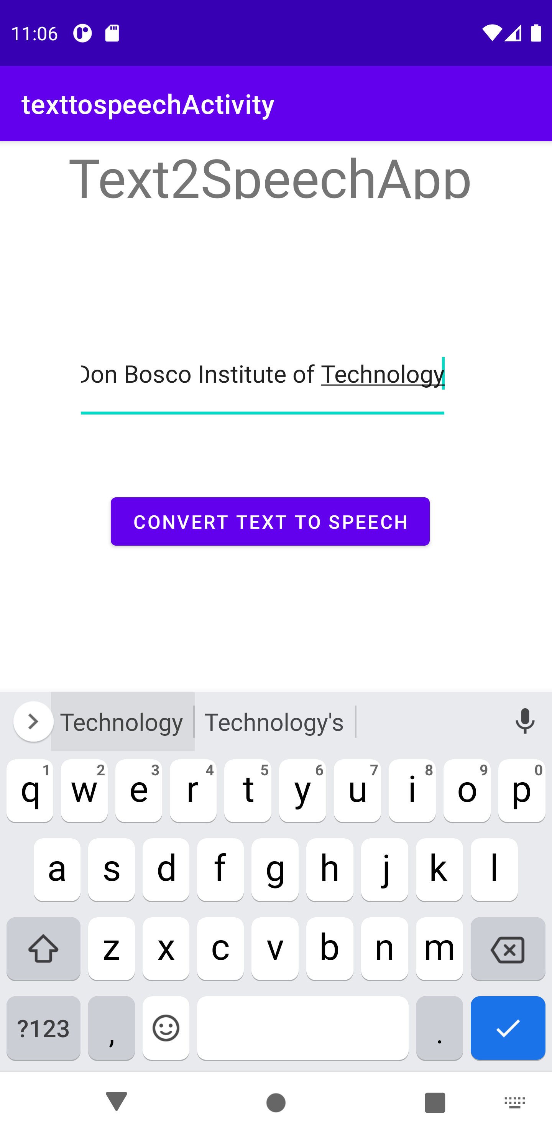

   Program-8: Create an activity like a phone dialer with CALL and SAVE buttons. On pressing the CALL button, it must call the phone number and on pressing the SAVE

   button it must save the number to the phone contacts.

   1. Firstly Create an Application by Name “CallActivity”
   2. Go to xml code of design change the layout to “RelativeLayout”

   3) Add TextView component & change the following properties:

   • Size: 38dp

   • Text: Call Activity

   • Center-Align

   4) Add EditText component & change the following properties in XML Code:

   • id: “@+id/phoneNumberEditText”

   5) Add PlainText(EditText) component & change the following properties in XML Code:

   • Text: “”

   • Hint: “Copied Text”

   • id: “@+id/editText2”

   6) Add three buttons to the design & change the text of the Buttons to “Clear”, “Call”, “Save” and change the id as follows:

   • id:”@+id/clearBtn”

   • id:”@+id/callBtn”

   • id:”@+id/saveBtn”

   7) Add twelve buttons to the design & change the text of the Buttons as 1,2,3,4,5,6,7,8,9,0,*,#

   XML-CODE

   *<?***xml version="1.0" encoding="utf-8"***?>*<**RelativeLayout xmlns:android="http://schemas.android.com/apk/res/android"  
   xmlns:app="http://schemas.android.com/apk/res-auto"  
   xmlns:tools="http://schemas.android.com/tools"  
   android:layout_width="match_parent"  
   android:layout_height="match_parent"  
   tools:context=".MainActivity"**>  
     
    <**TextView  
    android:layout_width="298dp"  
    android:layout_height="wrap_content"  
    android:layout_alignParentEnd="true"  
    android:layout_alignParentRight="true"  
    android:layout_alignParentBottom="true"  
    android:layout_centerHorizontal="true"  
    android:layout_marginEnd="56dp"  
    android:layout_marginRight="56dp"  
    android:layout_marginBottom="656dp"  
    android:text="Call Application"  
    android:textSize="36dp"  
    app:layout_constraintBottom_toBottomOf="parent"  
    app:layout_constraintLeft_toLeftOf="parent"  
    app:layout_constraintRight_toRightOf="parent"  
    app:layout_constraintTop_toTopOf="parent"** />  
     
    <**EditText  
    android:id="@+id/phoneNumberEditText"  
    android:layout_width="262dp"  
    android:layout_height="wrap_content"  
    android:layout_alignParentEnd="true"  
    android:layout_alignParentRight="true"  
    android:layout_alignParentBottom="true"  
    android:layout_centerHorizontal="true"  
    android:layout_marginEnd="123dp"  
    android:layout_marginRight="123dp"  
    android:layout_marginBottom="571dp"  
    android:ems="10"  
    android:inputType="phone"** />  
     
    <**Button  
    android:id="@+id/clearBtn"  
    android:layout_width="wrap_content"  
    android:layout_height="wrap_content"  
    android:layout_alignParentEnd="true"  
    android:layout_alignParentRight="true"  
    android:layout_alignParentBottom="true"  
    android:layout_marginEnd="16dp"  
    android:layout_marginRight="16dp"  
    android:layout_marginBottom="573dp"  
    android:text="Clear"** />  
     
    <**Button  
    android:id="@+id/button2"  
    android:layout_width="76dp"  
    android:layout_height="wrap_content"  
    android:layout_alignParentEnd="true"  
    android:layout_alignParentRight="true"  
    android:layout_alignParentBottom="true"  
    android:layout_marginEnd="288dp"  
    android:layout_marginRight="288dp"  
    android:layout_marginBottom="458dp"  
    android:onClick="inputNumber"  
    android:text="1"** />  
     
    <**Button  
    android:id="@+id/button3"  
    android:layout_width="76dp"  
    android:layout_height="wrap_content"  
    android:layout_alignParentEnd="true"  
    android:layout_alignParentRight="true"  
    android:layout_alignParentBottom="true"  
    android:layout_centerHorizontal="true"  
    android:layout_marginEnd="168dp"  
    android:layout_marginRight="168dp"  
    android:layout_marginBottom="456dp"  
    android:onClick="inputNumber"  
    android:text="2"** />  
     
    <**Button  
    android:id="@+id/button4"  
    android:layout_width="76dp"  
    android:layout_height="wrap_content"  
    android:layout_alignParentEnd="true"  
    android:layout_alignParentRight="true"  
    android:layout_alignParentBottom="true"  
    android:layout_marginEnd="55dp"  
    android:layout_marginRight="55dp"  
    android:layout_marginBottom="457dp"  
    android:onClick="inputNumber"  
    android:text="3"** />  
     
    <**Button  
    android:id="@+id/button5"  
    android:layout_width="76dp"  
    android:layout_height="wrap_content"  
    android:layout_alignParentEnd="true"  
    android:layout_alignParentRight="true"  
    android:layout_alignParentBottom="true"  
    android:layout_marginEnd="286dp"  
    android:layout_marginRight="286dp"  
    android:layout_marginBottom="378dp"  
    android:onClick="inputNumber"  
    android:text="4"** />  
     
    <**Button  
    android:id="@+id/button6"  
    android:layout_width="76dp"  
    android:layout_height="wrap_content"  
    android:layout_alignParentEnd="true"  
    android:layout_alignParentRight="true"  
    android:layout_alignParentBottom="true"  
    android:layout_centerHorizontal="true"  
    android:layout_marginEnd="169dp"  
    android:layout_marginRight="169dp"  
    android:layout_marginBottom="367dp"  
    android:onClick="inputNumber"  
    android:text="5"** />  
     
    <**Button  
    android:id="@+id/button7"  
    android:layout_width="76dp"  
    android:layout_height="wrap_content"  
    android:layout_alignParentEnd="true"  
    android:layout_alignParentRight="true"  
    android:layout_alignParentBottom="true"  
    android:layout_marginEnd="54dp"  
    android:layout_marginRight="54dp"  
    android:layout_marginBottom="363dp"  
    android:onClick="inputNumber"  
    android:text="6"** />  
     
    <**Button  
    android:id="@+id/button8"  
    android:layout_width="76dp"  
    android:layout_height="wrap_content"  
    android:layout_alignParentEnd="true"  
    android:layout_alignParentRight="true"  
    android:layout_alignParentBottom="true"  
    android:layout_centerVertical="true"  
    android:layout_marginEnd="290dp"  
    android:layout_marginRight="290dp"  
    android:layout_marginBottom="294dp"  
    android:onClick="inputNumber"  
    android:text="7"** />  
     
    <**Button  
    android:id="@+id/button9"  
    android:layout_width="76dp"  
    android:layout_height="wrap_content"  
    android:layout_alignParentEnd="true"  
    android:layout_alignParentRight="true"  
    android:layout_alignParentBottom="true"  
    android:layout_centerInParent="true"  
    android:layout_marginEnd="169dp"  
    android:layout_marginRight="169dp"  
    android:layout_marginBottom="291dp"  
    android:onClick="inputNumber"  
    android:text="8"** />  
     
    <**Button  
    android:id="@+id/button10"  
    android:layout_width="76dp"  
    android:layout_height="wrap_content"  
    android:layout_alignParentEnd="true"  
    android:layout_alignParentRight="true"  
    android:layout_alignParentBottom="true"  
    android:layout_centerVertical="true"  
    android:layout_marginEnd="57dp"  
    android:layout_marginRight="57dp"  
    android:layout_marginBottom="290dp"  
    android:onClick="inputNumber"  
    android:text="9"** />  
     
    <**Button  
    android:id="@+id/button11"  
    android:layout_width="76dp"  
    android:layout_height="wrap_content"  
    android:layout_alignParentEnd="true"  
    android:layout_alignParentRight="true"  
    android:layout_alignParentBottom="true"  
    android:layout_marginEnd="293dp"  
    android:layout_marginRight="293dp"  
    android:layout_marginBottom="216dp"  
    android:onClick="inputNumber"  
    android:text="#"** />  
     
    <**Button  
    android:id="@+id/button12"  
    android:layout_width="76dp"  
    android:layout_height="wrap_content"  
    android:layout_alignParentEnd="true"  
    android:layout_alignParentRight="true"  
    android:layout_alignParentBottom="true"  
    android:layout_centerHorizontal="true"  
    android:layout_marginEnd="171dp"  
    android:layout_marginRight="171dp"  
    android:layout_marginBottom="213dp"  
    android:onClick="inputNumber"  
    android:text="0"** />  
     
    <**Button  
    android:id="@+id/button13"  
    android:layout_width="76dp"  
    android:layout_height="wrap_content"  
    android:layout_alignParentEnd="true"  
    android:layout_alignParentRight="true"  
    android:layout_alignParentBottom="true"  
    android:layout_marginEnd="57dp"  
    android:layout_marginRight="57dp"  
    android:layout_marginBottom="214dp"  
    android:onClick="inputNumber"  
    android:text="*"** />  
     
    <**Button  
    android:id="@+id/callBtn"  
    android:layout_width="76dp"  
    android:layout_height="wrap_content"  
    android:layout_alignParentEnd="true"  
    android:layout_alignParentRight="true"  
    android:layout_alignParentBottom="true"  
    android:layout_marginEnd="229dp"  
    android:layout_marginRight="229dp"  
    android:layout_marginBottom="123dp"  
    android:text="Call"** />  
     
    <**Button  
    android:id="@+id/saveBtn"  
    android:layout_width="76dp"  
    android:layout_height="wrap_content"  
    android:layout_alignParentEnd="true"  
    android:layout_alignParentRight="true"  
    android:layout_alignParentBottom="true"  
    android:layout_centerHorizontal="true"  
    android:layout_marginEnd="115dp"  
    android:layout_marginRight="115dp"  
    android:layout_marginBottom="128dp"  
    android:text="Save"** />  
   </**RelativeLayout**>

   JAVA-CODE

   package com.example.callingapplication;

   **package** com.example.callandsaveapp;  
   **import** androidx.appcompat.app.AppCompatActivity;  
   **import** android.content.Intent;  
   **import** android.net.Uri;  
   **import** android.os.Bundle;  
   **import** android.provider.ContactsContract;  
   **import** android.view.View;  
   **import** android.widget.Button;  
   **import** android.widget.EditText;  
   **public class** MainActivity **extends** AppCompatActivity {  
    EditText **phoneNumberEditText**;  
    Button **clearBtn**,**callBtn**,**saveBtn**;  
    @Override  
    **protected void** onCreate(Bundle savedInstanceState) {  
    **super**.onCreate(savedInstanceState);  
    setContentView(R.layout.***activity_main***);  
    **phoneNumberEditText**=findViewById(R.id.***phoneNumberEditText***);  
    **callBtn**=findViewById(R.id.***callBtn***);  
    **saveBtn**=findViewById(R.id.***saveBtn***);  
    **clearBtn**=findViewById(R.id.***clearBtn***);  
     
    **clearBtn**.setOnClickListener(**new** View.OnClickListener() {  
    @Override  
    **public void** onClick(View v) {  
    **phoneNumberEditText**.setText(**""**);  
    }  
    });  
    **callBtn**.setOnClickListener(**new** View.OnClickListener() {  
    @Override  
    **public void** onClick(View v) {  
    String phoneNumber=**phoneNumberEditText**.getText().toString();  
    Intent intent=**new** Intent(Intent.***ACTION_DIAL***); *//it triggers the built in phone call functionality* intent.setData(Uri.*parse*(**"tel:"**+phoneNumber));  
    startActivity(intent);  
    }  
    });  
    **saveBtn**.setOnClickListener(**new** View.OnClickListener() {  
    @Override  
    **public void** onClick(View v) {  
    String phoneNumber=**phoneNumberEditText**.getText().toString();  
    Intent intent=**new** Intent(Intent.***ACTION_INSERT***); *//insert an empty item to the given intent* intent.setType(ContactsContract.Contacts.***CONTENT_TYPE***); *//Set the data type of the content in contacts, MIME type which provides directory of people* intent.putExtra(ContactsContract.Intents.Insert.***PHONE***,phoneNumber); *//extra field for contact phoen number, string constant used to create contact intent* startActivity(intent);  
    }  
    });  
    }  
    **public void** inputNumber(View V){  
    Button btn=(Button)V;  
    String digit=btn.getText().toString();*//5 //2* String phoneNumber=**phoneNumberEditText**.getText().toString();*//98 //984 //9845* **phoneNumberEditText**.setText(phoneNumber +digit);*//98+4 //984+5 //9845+2* }  
   }

   Output:

   |  |  |  |
   | --- | --- | --- |
   |  |  |  |

  